**THE OFFICIAL PUBLICATION OF ALOA - AN INTERNATIONAL ASSOCIATION OF SECURITY PROFESSIONALS**

**April 2001**

**Imagine, if you will...**

**a sprawling campus in the middle of the Inter-mountain West. Thousands of locks**

**Massive changeover**

You have just entered...



inals Stand Alone.

Only STRATTEC can supply the 2000 Taurus and Sable transponder keys, along with other original Ford, DaimlerChrysler, GM, and Mitsubishi models. Only STRATTEC is America's largest transponder key OE supplier. So only STRATTEC's keys hit the market the same time the new cars do. Alone among the competition, STRATTEC has the technological experience that comes with leadership. Nobody else offers the STRATTEC seminars that keep you up to date with the latest in security technology. Nobody else gives you that kind of support; the originals stand alone, so you don't have to.

599452 - Chrysler RFID Valet Key 89 Groove 690556

690222 - Chrys\er RFID Primary Key 84 Groove 690554

690224 - Chrysler RFID Valet Key 85 Groove 598333

690226 - Chrysler RFID Key 90 Groove 599902

S994S0 - Dodge RFID Key 90 Groove 599179

599455 - Dodge RFID Key 84 Groove 599114

690504 - jeep RFID Master Key 84 Groove 598992

690223 - Neon RFID Key 84 Groove 599479

690552 - General Motors 75 Groove RFID Key

■ General Motors Primary 88 Groove RFID Key

* General Motors Valet 75 Groove RFID Key
* Ford Primary Molded 82 Groove PATS Key
* Ford Primary Molded Encrypted 82 Groove PATS Key
* Mercury Sable Primary Molded Encrypted 82 Groove PATS Key
* Ford Taurus Primary Molded Encrypted 82 Groove PATS Key
* Mitsubishi Primary Molded 90 Groove RFID Key
* Mitsubishi Valet 89 Groove RFID Key

s1~RATT£c

mt

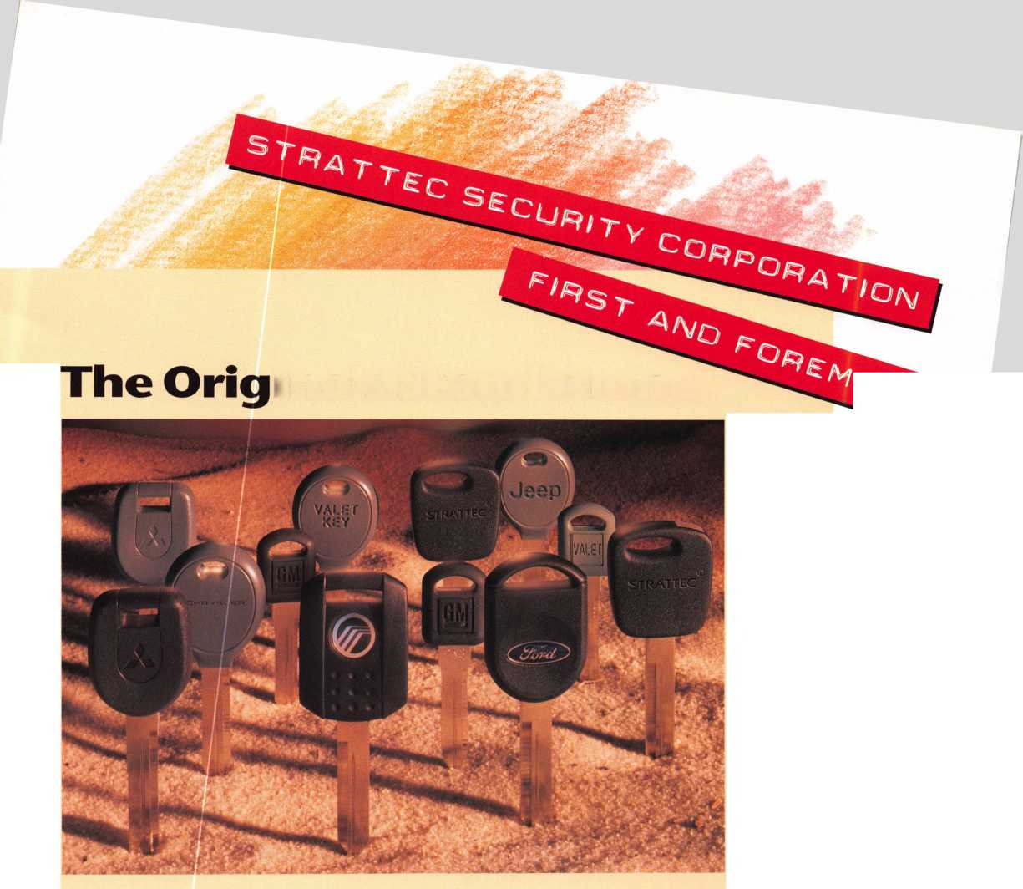

LOA 2001

year one.

do you know what to expect

when tomorrow arrives?

, -. HP

J8L .jHttL.I

witness the unexpected july 15-22

at baltimore convention center.

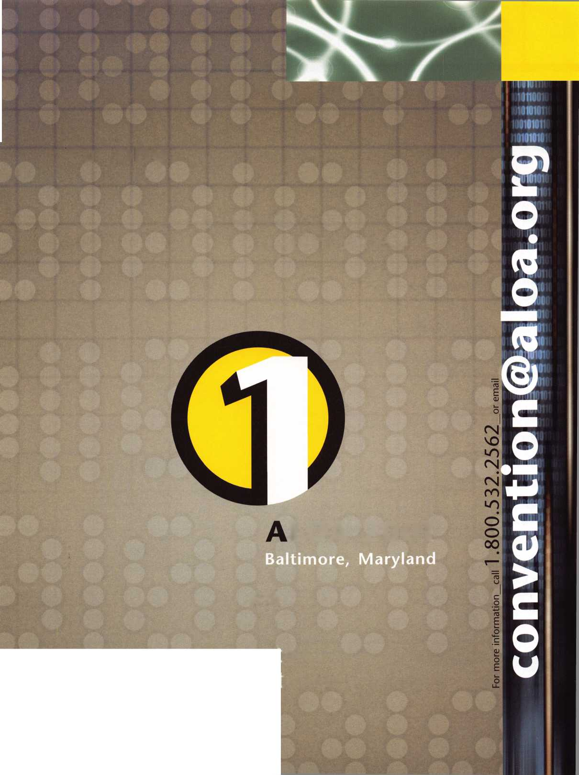

April 2001

Volume 47, Issue 4

CO

iu

OC

D

I-

<

Ul

IL

2 I Keynotes

4

**President’s Journey**

By John Greenan, CML, CPS

28

Cover- Institutional Locksmithing:

**The Institutional Zone**

When he arrived at Utah State University overlooking the western Boundary of the Rockies nested in the Intermountain west of Utah, our trusty master locksmith realized he was in for quite a ride. With more than 20,000 students on a 400-acre sprawl of a campus, USU is a headache of a job with just about every lock application you can imag­ine. And it's over a hundred years old. At the conclusion of this adven­ture, you'll be institutionalized.

By Roger Yost, CML, CPS

16

Traditional Locksmithing:

**Door Installations Made Simple**

Sometimes a tool is worth the time it saves you. That's the case with the new Wild Jig from Locktools.com.

By Sal Dulcamara, CML

20

**Protecting Your Facility From Today's Vandals**

Vandalism is easy. Vandal-proofing your facility is a step-by-step exer­cise in patience, focus and analysis. Follow the steps with this in- depth tutorial.

By Denise Lopez

24

Automotive:

**The Transponder Dillemma**

Outside of all the hoopla, there's really only one way to determine whether transponder work is the right choice for your business. You need to seriously ask, what does it mean to the bottom line?

By Tom Seroogy, CML

34

**Inside IDN**

An insiders look at one of the industry's foremost distributors.

By Karen Hoffman

36

**Ready for Fire?**

Is your business prepared for disaster? You would hate for it to happen, but if it does, knowing how to handle it will minimize your headaches.

By Steve Goodwin

DEPARTMENTS

4

President's Journey

6

Upcoming Events

8

Core

12

Security Marketplace

14

Applicants

38

Legislative Update

40

Classifieds

42

Associate Member Listing

44

Back Page

April 2001

|  |  |  |  |
| --- | --- | --- | --- |
| Editor | Jim DeSimone [editor@aloa.org](mailto:editor@aloa.org) | Executive Director | Charles W. Gibson, Jr., CAE [charlie@aloa.org](mailto:charlie@aloa.org) |
| Technical Editor | David Lowell, CML, CMST |  |
|  | [david@aloa.org](mailto:david@aloa.org) | Meetings Manager | Kelly Carr, CMP [kelly@aloa.org](mailto:kelly@aloa.org) |
| Editorial Advisor | John D. Cannon, CML |  |
|  | j dcannon @ worldnet. att. net | PRP/Education Manager | David Lowell, |
|  |  |  | CML, CMST |
| Art Director | Lindsay Magers [lindsay@aloa.org](mailto:lindsay@aloa.org) |  | [david@aloa.org](mailto:david@aloa.org) |
| Advertising Sales | Susan Haverkamp | Operations/Membership Manager | Mary May [mary@aloa.org](mailto:mary@aloa.org) |
|  | 121 Davis Street |  |
|  | Nacogdoches, Texas 75961 | Director of Information Technology | Randy McChristian |
|  | Phone: (936) 569-7172 VoiceMail: (208) 248-8893 | [randy@aloa.org](mailto:randy@aloa.org) |
|  |
|  | e-mail: [adsales@aloa.org](mailto:adsales@aloa.org) | Government Affairs Manager/ Chapters & Regional Associations Liaison | Tim McMullen [tim@aloa.org](mailto:tim@aloa.org) |
| Contributors | Jerome Andrews, CML |
|  | Paul Chandler, CRL  Claire Cohen, CML | Comptroller | Kathy J. Romo |
|  | Brian Costley, CML, CMST | Network Specialist | Greg Jackson |
|  | Ray D'Adamo, CML  Sal Dulcamaro, CML | Membership Coordinator | Shelly Jett |
|  | Billy Edwards, CML | PRP/Education Coordinator | Ashley Manson |
|  | Dan Graffeo, CRL,CMST  A.J. Hoffman, CML | Accounting Coordinator | Kathy Stokes |
|  | Jeff Nunberg, CML, CMST | Mail Room Coordinator | Humberto Cerda |
|  | Mikey Oehlert, CPL, CPS |  |  |
|  | Randy Simpson, CML  Robert Stafford, CML | Receptionist | Alin Valdez |
|  | Dave Thielen, CML  Greg Perry, CML,CPS |  |  |
|  | Tom Seroogy |  |  |
|  | Charles Stephenson, CPS |  |  |
|  | Dennis Watanabe, CML, CMST |  |  |

Additional contact information for the ALOA Board and most Keynotes authors is available through “Locksmith Search'" on the ALOA Web site- [www.aloa.org](http://www.aloa.org) or by contacting the ALOA office at 3003 Live Oak Street; Dallas, TX 75204; [800)532-2562;

FAX [214)827-1810; e-mail [aloa@aloa.org](mailto:aloa@aloa.org).



President

John J. Greenan, CIVIL, CPS (773] 486-2030 [fsl.john@mindspring.com](mailto:fsl.john@mindspring.com)

Secretary

John D. Cannon, CML (703] 960-6413 [jdcannon@worldnet.att.net](mailto:jdcannon@worldnet.att.net) Directors, Northeast John C. Magee, III (856] 845-3434 Peter Sarailian, CRL (201] 947-6291 [psarailian@yahoo.com](mailto:psarailian@yahoo.com) William L. Young, CML (610] 647-5042 Directors, Southeast Thomas W. Tate (850] 476-4211 Donald E. Rul6, CML

1. 324-2658 [rulecml@ebicom.net](mailto:rulecml@ebicom.net) Directors, North Central Mark E. Blum, CML, CPS (517) 482-5809 [mblum@arq.net](mailto:mblum@arq.net)

Tom Ripp, CRL (608) 262-3831 Director, South Central Randy L. Simpson, CML (713) 780-7026 Directors, Southwest Gordon R. Racine, CML (719) 384-4707 [aloaswdir@excite.com](mailto:aloaswdir@excite.com) John A. Ilk, CRL

1. 420-2174 [getreil@yahoo.com](mailto:getreil@yahoo.com) Director, Northwest Scott L. Henke, CRL, CPS (907) 248-3785 [action@alaska.net](mailto:action@alaska.net)

Director, Associate Members

David F. Matthies

(727) 541-5536

[dmatthies@southernlock.com](mailto:dmatthies@southernlock.com)

Trustees

Dallas Brooks

(334) 826-8990

David M. Lowell. CML, CMST

(800) 532-2562

Breck H. Camp, CML

(770) 455-6244

Edwin Toepfer, RL

(416) 225-5589

Mission Statement: The Associated Locksmiths of America, Inc. is dedicated to enhancing the professionalism, education and ethics among locksmiths and those in related sectors of the physical security industry. With approximately 10,000 members in the United States, Canada and the freeworld, ALOA is poised to help members obtain the knowledge, the strength, and the confidence to perform their role in the physical security field with pride and dignity. But it is only through active involvement and participation that ALOA can fully achieve its potential-and can help members to achieve theirs.

Policies: Keynoted is the official publication of the Associated Locksmiths of America, Inc. (ALOA). Keynoted acts as a moderator without approving, disapproving, or guaranteeing the validity or accuracy of any data, claim, or opinion appearing under a byline or obtained or quoted from an acknowledged source. The opinions expressed by the authors do not necessarily reflect the official views of ALOA. Also, appearance of advertisements and new products or service information does not constitute an endorsement of products or services featured by the Association. The Association does not accept responsibility for the inaccuracy of any data, claim, or opinion appearing in this publication, due to typographical errors on the part of the authors, Association staff or its agents. Editor’s Note: This publication is designed to provide accurate and authoritative information in regard to the subject matter covered. It is provided and disseminated with the understanding that the publisher is not engaged in rendering legal or other professional services. If legal advice and other expert assistance is required, the services of a competent professional should be sought.

Authors’ Payment: Payment for eligible submissions to Keynotes will be based on the following criteria: topic, time spent and past contributions. Authors who regularly submit to Keynotes are generally paid a higher rate. The latter is especially true of authors who write to fit specific editorial needs and submit said copy by Keynotes deadlines. As a general guideline: Average payment for a 750 word, business or light’ technical article would be $200. Payment for a 1500 word article involving significantly higher time and research efforts would be $400.

Payment will not be offered for articles submitted by ALOA employees or members of the ALOA Board of Directors (unless material is of a technical nature), nor for articles submitted by a company that promote that company’s products or services. ALOA reserves the right not to pay for articles submitted by an individuals) that promote a particular company’s products or services.

Disclaimer: The Associated Locksmiths of America, Inc., (ALOA), reserves the right to refuse any article for any reason. Additionally, ALOA reserves the right to edit, amend or modify any article submitted for publication in order to preserve technical accuracy, clarity, fairness or grammatical correctness. ALOA will make the best efforts to notify the author of any changes. The extent of ALOA’s liability for any article or information contained therein will be a notice of correction or retraction in the next possible issue.

Keynoted* (ISSN 0277 0792) is published monthly except for the combined June/July issue by The Associated Locksmiths of America, Inc., 3003 Live Oak St., Dallas, TX 75204-6186. Telephone: (214) 827-1701: FAX (214) 827-1810; e-mail [aloa@aloa.org](mailto:aloa@aloa.org). Subscription rates for members-$l 5.00 per year. Second class postage paid at Dallas, Texas. POSTMASTER: Send address changes to: Keynotes, 3003 Live Oak St, Dallas, TX 75204-6186. © Copyright 1999, All rights reserved. No part of the contents may be reproduced or reprinted in any form without prior written permission of the publisher.

Past Presidents

1997-1999 Dallas C. Brooks 1995-1997 David Lowell, CML, CMST 1993-1995 Breck Camp, CML 1991-1993 Henry Printz, CML 1989-1991 Evelyn Wersonick, CML, CPS 1987-1989 Leonard Passarello, CPL 1985-1987 Joe Jackman, CML 1983-1985 Stanley Haney, CPL 1981-1983 Louis LaGreco, CPL 1979-1981 John Kerr, RL 1977-1979 Clifford Cox, CML 1974-1977 Charles Hetherington 1972-1974 Gene Laughridge 1970-1972 William Dutcher, RL 1968-1970 Constant Maffey, RL 1966-1968 Harold Edelstein, RL 1964-1966 William Meacham 1962-1964 Robert Rackliffe, CPL 1960-1962 Edwin Toepfer, RL 1956-1960 Ernest Johannesen

***April 2001***

***Keynotes***

ALOA preaches unity for a reason, but it may not be the reason you think.



Pitching security professionals to the public as a unified, focused, structured group of ethical and knowledgeable individuals is a benefit on either sides of the lock shop counter. Your customers don’t have to deal with the con­fusion of finding a “good guy,” and you don’t have to use flimsy persuasion to win them over. Your ALOA PRP cer­tification speaks much louder than, “I’m a good locksmith just because.”

In that spirit, I’m pleased to announce this month that we’re offering new, categorized coverage in Keynotes. (If you have questions, send them to [editor@aloa.org](mailto:editor@aloa.org).) In the past, we’ve had special issues covering one topic, and we will still highlight certain themes each month with fea­ture material aiming to thoroughly cover a particular area of our profession. In addition to that, we will begin running a series of five departments covering five broad cate­gories of the security industry. Those five categories, in alphabetical order, are: access control, automotive, tradi­tional locksmithing, institutional locksmithing and safes. In this issue, we have a nice mix of articles as we often had in the past. The difference now is that you can count on these sections being there each month. It’s part of our commitment to offering superior service to the cream of the crop in our profession.

Just the fact that you are an ALOA member sets you far apart from other technicians in this industry. If you are pursuing a PRP certification, you’ve set yourself apart once again. The bottom line is that ALOA members are active security professionals. You’ve invested time and money for the greater good of your profession - a major distinction no matter what your line of work is. Most ALOA locksmiths are in charge of their shops, and if they aren’t - they probably will be someday soon. Over 63 percent of our members pass the magazine onto other readers.

That’s what it’s all about. Sharing and growing in your field. And that’s why ALOA is about more than just killing bad legislation and putting on a great convention every year. It’s about consistent interaction between the best in the business. Hope you enjoy the new approach!

Sincerely,



John J. Greenan CML, CPS

Keynotes

***April 2001***



ffrifil

***Visit our Website on  
www. stamcctv. com***

THE COMPLETE

CCTV PROGRAM ON CD-ROM  
FOR STAFF TRAINING AND

PRODUCTIVITY ENHANCEMENT

STAM **Insight** has been  
developed to enhance CCTV  
skills and productivity with  
many different uses.

**Ill** Productivity

H System Drawing  
H Estimation  
**#** CCTV Training  
I# CCTV Reference  
I# Sales/Demo  
t# System Design  
10 Staff Evaluation

|  |  |  |  |
| --- | --- | --- | --- |
| 1 | INFOMATE WORKMATE | | ULTIMATE 1 |
| y 1 CCTV Content | 10 hours | 10 hours | 14 hours |
| CCTV Calculators | / ! | /f  IS | / |
| O  | Demonstration Tool | r . | / | € |
| g | Estimation | m |  | . / |
| Hi Drawing | No 3 | f : r j | |
| £ | Internet Enabled | Mo | r : | £ |
| f Pre-Test | Mo f | Ho 1 / | |
| ? I  ,e I Quizzes | ho ' r | Mo | i. c |
| 1 M Knowledge Assessment | No | Mo | / i |

**Sold**

Distributed by:



**Over 50 Countries**

I

3003 Live Oak Street  
Dal las, Texas 75204

COPYRIGHT © 1996 Security Training and Marketing Pty Ltd.  
All rights reserved ACN 057 006 541

**Country**

Tel: ( )

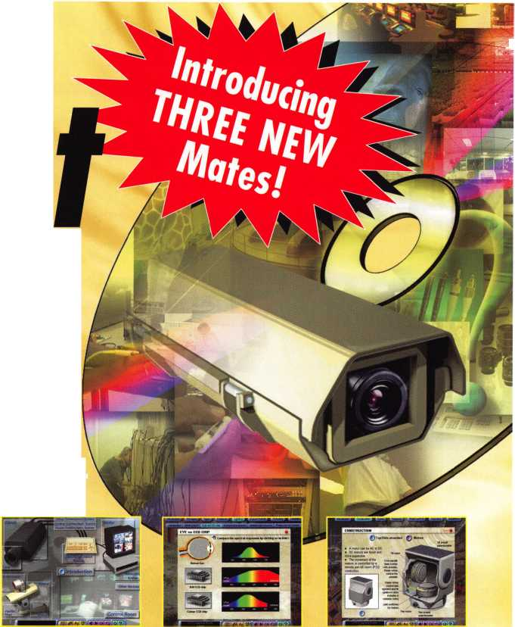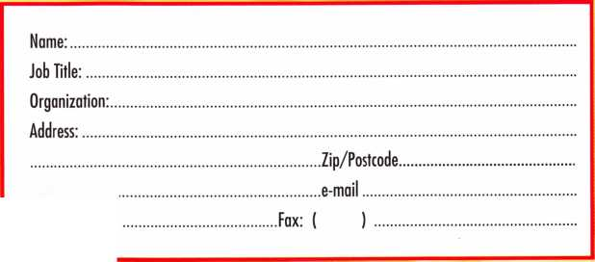

**even t a**

2001

April

4-6

ISC Expo/ West 2001 Las Vegas, NV

Sands Expo & Convention Center

7

Motorcycle Locksmithing Gateway Locksmithing Association Missouri

Kenneth Kim, CRL (314) 351-7252

13

ALOA PRP Sitting Dallas, TX

Contact: Ashley Manson (214)827-1701 (214) 827-1810 fax

14

**&** ALOA PRP Sitting White Bear Lake, MI Minnesota Chapter of ALOA Contact: Alan Morgan (763) 566-2637

21

Wyoming Locksmith Association Spring Meeting and Class “Automotive Transponder - Hands On”

Days Inn Casper, Wyoming Contact: Gene Ficek, CPL 605/642-4542

22

**?** ALOA PRP Sitting Ohio Valley Chapter of ALOA Fairborn, OH 937/836-6127

MAY

5

SAFETECH 2001 St. Louis, MO (214)827-7233 IDET 2001

6th International Exhibition of Defense and Security Technology

5

Georgia Chapter of ALOA Chamblee, GA

Contact: Stephen Gebbia, CML 770/455-6244

1. 11

Fairgrounds Brno, Czech Republic Contact: Messe Dusseldorf 312/781-5180

e-mail: [info@mdna.com](mailto:info@mdna.com) <<mailto:info@mdna.com>

1. 13

/ ALOA PRP Sitting

IDN 2001 Trade Show & Security Conference

Ypsilanti, MI

Contact: Fred Strasberger

(800)521-0955 or

Bonnie Weston

(734)591-1150

11

ALOA PRP Sitting Dallas, TX

Contact: Ashley Manson (214)827-1701 (214) 827-1810 fax

19

Grand Canyon Chapter of ALOA Introduction to Access Control Phoenix, AZ Contact: John Ilk, CRL 602/420-2174

JUNE

3

North Jersey Master Locksmith Association

1. th Annual Flea Market and Swap Meet Quality Inn Lyndhurst, New Jersey (201)944-7547

8

**&** ALOA PRP Sitting Dallas, TX

Contact: Ashley Manson (214)827-1701 (214) 827-1810 fax

14-17

New Mexico Locksmith Association NMLA Convention 6 VARIOUS ACE CLASSES Ruidoso, NM Contact: Steve Smith 505/281-6777

24

**^** ALOA PRP Sitting Sacramento, CA Clark Security Products Contact: Joan Emrick (619)718-7308



***Keynotes***

***April 2001***

JULY

13

ALOA PRP Sitting Dallas, TX

Contact: Ashley Manson (214)827-1701 (214) 827-1810 fax

15-22

ALOA 2001 Security Expo Baltimore, MD (800)532-2562

AUGUST

10

ALOA PRP Sitting Dallas, TX

Contact: Ashley Manson (214)827-1701 (214) 827-1810 fax

SEPTEMBER

14

**t** ALOA PRP Sitting Dallas, TX

Contact: Ashley Manson 800/532-ALOA (2562)

(214) 827-1810 fax

27-28

MINK Convention Contact: Elmer Howard (402)330-8701

OCTOBER

12

**^** ALOA PRP Sitting Dallas, TX

Contact: Ashley Manson (214)827-1701 (214) 827-1810 fax

15-21

Tri Regional Locksmith Conference Portland, OR

Pacific Locksmith Association Contact: Stan Hauer (503)325-7334 Email [hauer@pacifier.com](mailto:hauer@pacifier.com) Contact: Ken Mead (503) 873-6932

* Super bearing construction.
* Superior rigidity and accuracy.
* Shipped with carbide cutter.
* 2 year parts and labor warranty.
* Increased cut rates:

Laser mode 8 seconds.

Standard mode 12 seconds,

Bi Axial 6 pin 17 seconds.

* New Medeco Autoswing head option.

□1)®M

WEAR EYE PROTECTION

* Up to 800 built-in manufacturer depths and spaces.
* Works with most popular Master key systems.
* Serial port to communicate with user systems.
* Repeatable accuracy of l/1000th inch.
* Dependable heavy duty construction.
* 1 year parts and labor warranty.
* Cuts Medeco™ High Security keys with angled cuts.

The ITL 9000 was built by locksmiths — we know what you wanted so we built it. When a new lock comes out you add the space and depths immediately. No Mechanical adjustments. All sealed and prelubricated bearings.

Uses either 12 or 120 volts.

All manufacturer depths and spaces built in, Heavy duty construction.

12 month warranty.

Built in Master key System.

TOOLS LIMITED

— **Now Distributed Throughout USA, Canada & Australia**

2639B Progressive Way • Abbotsford, BC Canada V2T6H8 USA: 562-699-0060 • Canada: 604-852-8904 • Canada Fax: 604-852-8938 • Tell Free: 1-8

Keynotes

***April 2001***

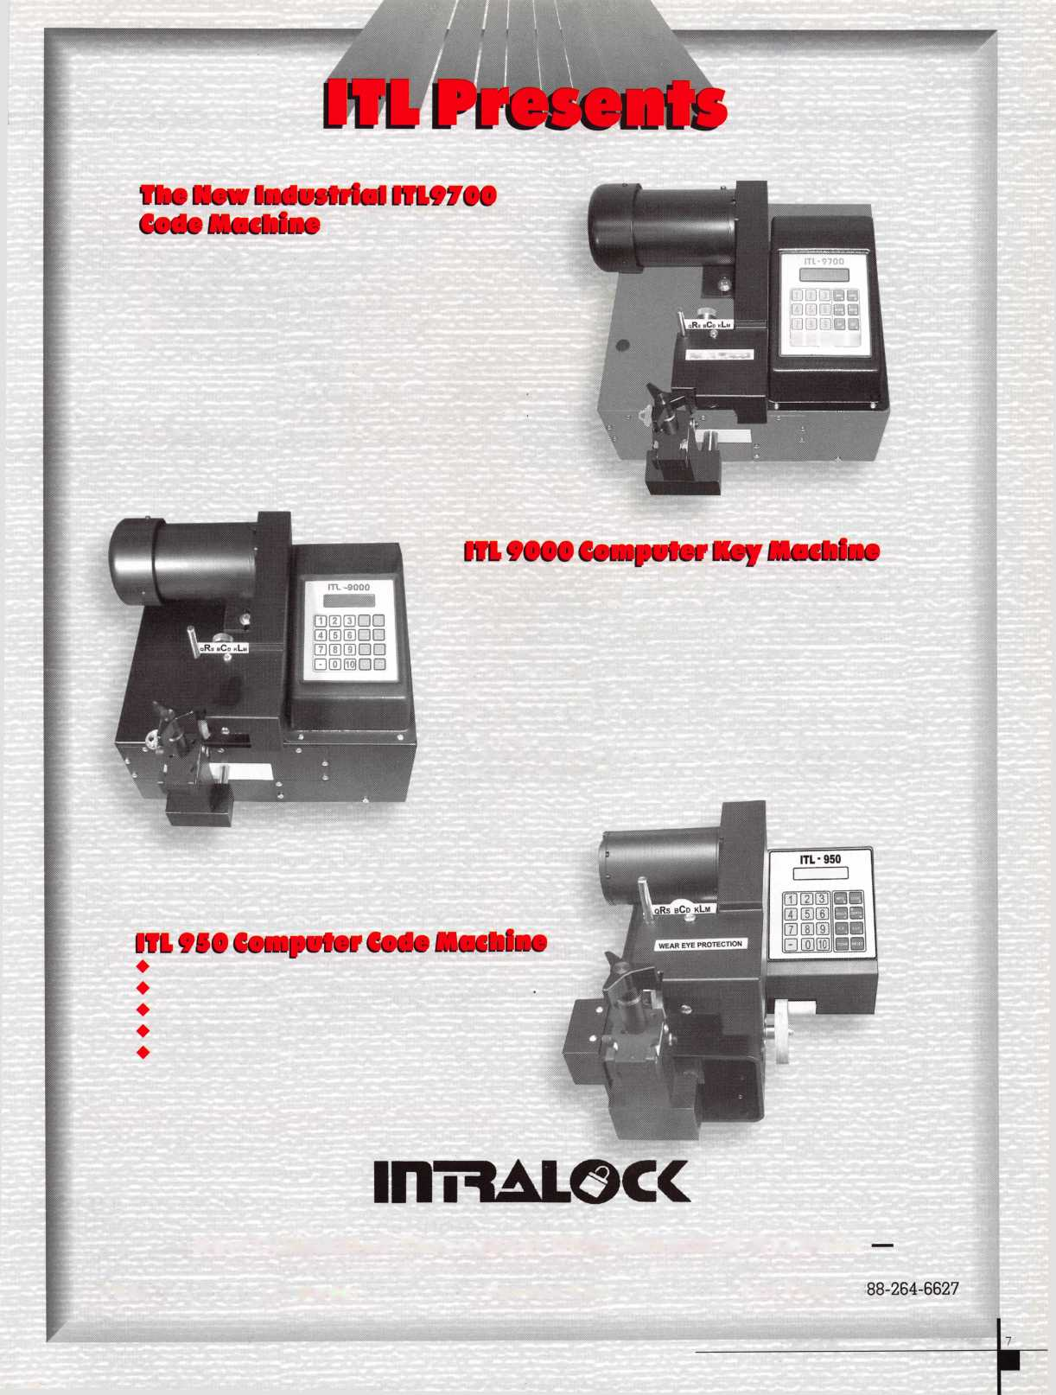

CORE

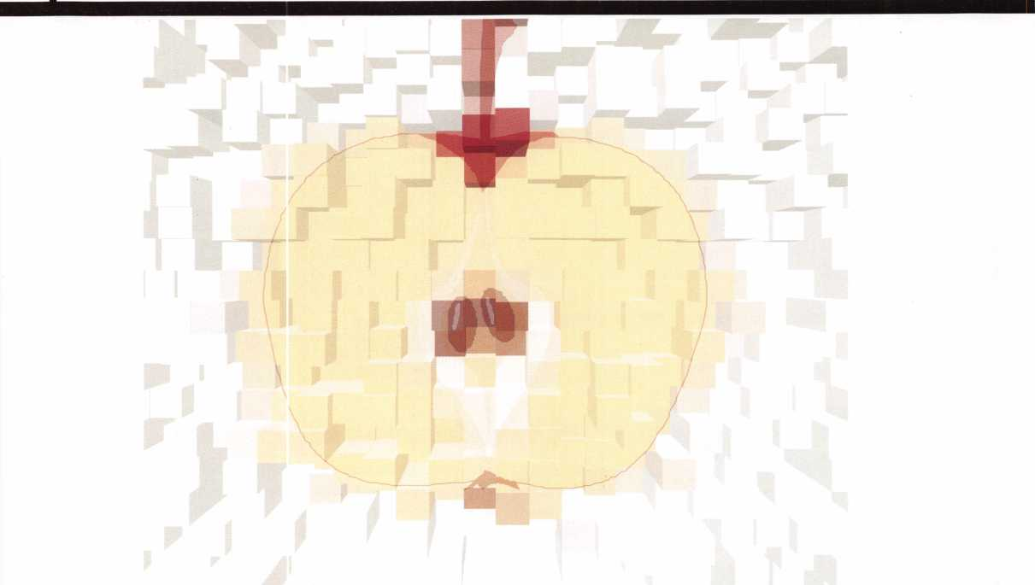

ALOA Member Russ Rackliffe Passes Locksmithing Sting Test

ALOA members just can’t get the wool pulled over their eyes by locksmith sting operations. That’s what Russ Rackliffe proved when a news station in Connecticut tried to expose the poor safety standards of some lock­smiths. Not Rackliffe.

The story began by pointing out that locksmiths often come to the rescue when people are locked out. But the undercover investigation sought out locksmiths who don’t always know who they are letting in.

“I need to see some identification.” It’s a question you’d hope all locksmiths ask. But do they?

From the story:

“The locksmith from Rackliffe followed procedure. Right away he demanded ID. Offering a credit card as

ID, the locksmith told our producer “that doesn’t tell me you live here.” Unsure, the locksmith refused to open the door. We showed our video to his boss, Russ Rackliffe. “He called me on the cell phone and said, Took, this lady has nothing.’ We agreed - leave,” Rackliffe said. “We do have certain standards we try to maintain.”

Rackliffe, which passed our test, says it’s not always easy getting proof. “We do our best to record everything in case there is a problem,” Rackliffe said. He says home- owners need to feel protected. “You don’t want this to happen to anyone.”

In Connecticut, there are no state standards for lock­smiths.

Russ Rackliffevs Locksmith Test - Safety Tips

Here are some tips Russ Rackliffe of Rackliffe recom­mends in a lockout situation

1. Cariy an spare key or keep one with a trusted friend or neighbor.
2. Keep and extra key in your wallet or purse.

3.If someone is house sitting for you let local

***Keynotes***

***April 2001***

police know you’re away and who is staying or checking your home.

1. Give housesitters two keys in case they lock one inside.
2. Give friends or relatives a spare key to your home in case a housesitter gets locked out.
3. Let housesitter know who to contact in a lockout situation.
4. Not a good idea to hide a key under the mat or flower pot. It’s the first place a burglar will look.

If you have questions you can contact Russ Rackliffe at (860) 388-1810 or at *www. rackliffelock.* *com* <<http://www.rackliffelock.com>>. Find out more information from ALOA’s (<Positive ID Policy” available on the Web at [www.aloa.org/about](http://www.aloa.org/about)! id.cfm < http://www.aloa.org!about!id.cfm >. It is also listed in the following Core note.

ABC Locksmith in

Miami: “Locksmiths Beware!”

There are some problems in busi­ness that are universal. Securing some new customers, overcoming unseen delays and supply problems are only a few of them. But perhaps none are more trouble than an account that won’t pay. Or worse, an account that makes money from the jobs you do and STILL won’t pay.

That was our experience recently with a national service company. Sub-contracting for a major retailer, they contacted us when a store in

our area needed lock work. At that point, we would agree to do the

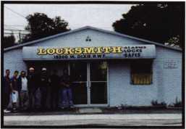

work and the sub-contractor would fax us a purchase order, with the store location and the list of what they wanted.

Unfortunately, when we billed the sub-contractor upon completion of the work, they refused to pay. We had already provided the services exactly as they had instructed, and then the nightmare began: The peo­ple who owed us money vanished.

We tried to contact them over a period of several months, and got no response. We tried to be patient, giv­ing them every opportunity to vol­untarily settle the account, but to no avail.

We finally contacted our attorney, who sent them a letter of warning. Within 24 hours, they called us wanting to make suitable payment arrangements.

The moral of the story? Don’t let outstanding balances on your accounts build up simply because you are doing business with a major retailer. That’s no guarantee that you will be paid.

Remember to make sure to tell your accounts receivable people to inform your dispatcher when an account

gets more than 60 days past due, or has a high balance. Make a list and post it where it can be seen by all employees.

When the company tries to call you to do more lock work, politely inform them that their account needs to be brought up to date before any more assignments will be accepted.

Also, when a company is on a pur­chase order system, make sure you save the original paperwork with the invoice. This way, if you must turn them over to collection authorities, you will have the records you need to get paid.

If you are able to process credit cards, remind them you will accept credit card payments by phone, for their convenience. Sometimes even a company with strict guidelines for paying invoices will surprise you by calling with a credit card to cover an overdue balance. Their monthly statement is a perfect place to include polite reminders about pay­ment.

Following these steps will save you from wasting time, energy and sup­plies on jobs that don’t pay.

— Adrienne Coley

Jersey Appointment

New Jersey member Richard Rible was recently honored with a re­appointment by New Jersey Governor Christine Todd Whitman

***April 2001***

Keynotes

CORE

as a member of  
the state’s Fire  
Alarm, Burglar  
Alarm and

Locksmith  
Advisory  
Committee.  
ALOA congratu-

lates Richard for the continued excel-  
lence.

REGIONS

GPLA Notes

Jack Magee of the Greater Philadelphia Locksmiths Association kept the GPLA presence alive in Texas last month with his visit to the Texas Locksmith Association’s annual convention, which took place in Austin. Look for GPLA to have a strong showing at the Master Locksmith Association of New Jersey’s annual show, taking place this month in New Jersey. And of course, expect the GPLA to hold a dandy show of their own later this year.

One final note ... the members of GPLA are looking into a good idea that may be on the minds of lots of other members on the east coast: They’re hoping to charter a bus to Baltimore so members can travel to the ALOA 2001 Security Expo in style. Sharp cookies, those GPLA guys ...

Tech Tip

I was working on a 1991 Hyundia and could not pick the ignition to the on

position in order to remove it. The owner gave me permission to drill it out. After taking off the face covers, I discovered there was plenty of mate­rial in the plug to drill a hole under the retainer and tap it up to remove the cylinder. I would suggest using a 9/64 or 5/32 drill bit (no larger) and only drill deep enough to clear the retainer. After removing the lock, remove the snap-ring and push the plug out the front. If you find num­bers on the tumblers, they will be in reverse: 1=4, 2=3, 3=2, 4=1. Cut the new key and reassemble. After replacing the face covers, there is no sign any­thing has been done. I had to do this, as the ignition had been changed out before and used a different key than the others.

—Bert Watson, Westminister, Colo.

New Certifications

CRLs: Robert W Harris FortWorth, TX Bob McCleary Hudson Oaks, TX

MAILBOX

Dear Friends,

Maybe this litle story will help or you can start helping the locksmiths out there. My recent employment with controls operation in Washington state finally came to a head and many heated discussions regarding the locksmiths working on fire doors and no one really confirming whether these doors con­tained asbestos fibers or not. Not knowing better (never have I received any education regarding fire doors and asbestos hazards as a locksmith) we and many before me had worked on these

doors, installing, repairing or whatever on these doors. We had finally decided that the locksmiths would not work on these doors and they would have to contract an approved asbestos company for this purpose. Problem is, there are NO CERTIFIED ASBESTOS LOCKSMITHS!!! The companies are trained to work on removing asbestos, but not what we often were required to do. Now that I have departed and move on, I hear from my friends there, that an outside contrac­tor locksmith (?) was hired to install some hotel type lock on the Bachelor Enlisted buildings and now has exposed everyone and all of the buildings he retrofitted these locks on to asbestos or asbestos related fibers. I have a copy of the review of the findings. Now, the Navy wants to sue the locksmith. I really wonder if that was just there way of taking care of a problem they refused to handle a year or so ago, when we sug­gested total replacement of those doors due to the exposure possibilities to the tenants and the employees. HUMMM- MMMM????? Well, do you know of any educational materials ever being taught to locksmiths on this subject, and shouldn’t we have such training? Please pass this on to whomever you think might be able to help.

—Chuck Pigue, Seattle, Wash.

OBITS

John S. Kranjec

ALOA member John S. Kranjec recent­ly passed away. Kranjec was the founder and owner of Locksmiths and Safemen Security Hardware Ltd. In Brampton, Ontario.



Keynotes

***April 2001***

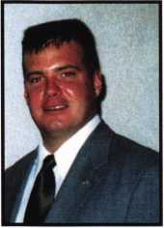

The Brightest And The Best

Robert C Rodocker CRL  
James E Gruber CRL  
Michael E Jordan Jr, CML  
James T Brickler CRL  
Joseph C Fuller CML, CMST  
Leonard J Passarello CPL  
Frank D Flartung CML  
Joseph W Whitaker CPL  
Robin A Florsley  
Paul M Souber  
Donald H Shiles RL

Kwok-kei Leung 202

Toshihiro AsANO 108

Flenry W Raymond 100

Yuriko Yanai 68

Mary S Ohmit CPL 66

Charles C Robertson CML 65

Jack Hobbin 51

William B Neff CML 43

Salvatore J Dulcamaro CML 40

Myeong-Rae Cho 38

Dana L Barnum CML 35

Barry K Leas CRL 35

David M Lowell CML, CMST 34

Danny W Rudd CPL 31

Larry A Warnick CML 31

Jeanne G Lodge CML 31

C Allan Halveerson 31

Breck H Camp CML 27

Dallas C Brooks 27

Lawrence F Smith Jr, CML 26

Anthony J Ramunno CML, CPS 26

James M Watt CML, CPS 26

Jeffrey S Nunberg CML, CMS 26

J Thomas Hood 26

Jim Williams 26

James H Glazier Sr, CML 25

Robert H Stafford CPL 25

William Lee 25

John C Elliott Jr, CML 24

Scott L Henke CRL, CPS 24

Jerome L Cohen CML 23

Peter K Gauthier CPL, CPS 23

Robert F Carroll CPL 23

Elvis D Hammerschmidt CPL 23

Robert D DeWeese CML 23

Marian M Swann CRL 22

Diana R Barnum CRL 22

Man S Seo 22

James J Cawby CML, CPS 21

Eugene R Altobella Sr 21

John L Shandy CML 19

Hans Mejlshede CML 19

John S Dorsey CML 19

D Michael Robinson CRL 19

Robert W Duman Sr, CML 19

Philip A Rovenolt CPL 19

Michael B Groves 19

James E Fowler Sr, CML 18

David C Harris CML 18

Peter R Hall 17

Thomas G Vandersteen CML, CPS 17 William P Grant CRL 17

Keizo Takahashi CRL 17

Evelyn V Wersonick CML, CPS 16

Joseph P Ferrero CML 16

Gary F Teams CPL 16

Michael D Robinson CRL 16

Brian J Reetz 16

Maurice Benson 16

Walter W Lascar RL 15

William J McElheney CML 15

Jon B Griswold CML 15

Russell P Fuller CRL 15

Daniel L Landry Jr 15

John A Ilk CRL 13

Richard C Sievers 13

Joe J Lee CRL 13

Ernest W Wright 12

Rolando 12

John D Cannon CML 12

Raymond C Lusk CML 12

John F Engel CRL 12

Eric F Veal 12

Basil W Shannon CPL 11

William J Wickward CML 11

Calvin G Harris CML 11

Herbert C Dusenberry CML, CPS 11 Timothy K Chow 11

John J Greenan CML, CPS 11

William L Young CML 11

Dale L Knowles CPL 11

Thomas J Demont CML, AHC 10

Alvin N Minor 10

Gene 10

Ronald P Riggins CML 10

Lester S Brodsky 10

Larry L Votaw CM L 10

Thomas R Smith CPL 10

William T Straub CML 10

Richard T Johnson CPL 10

Dale V Crosby CPL 10

James V Hawley CRL 10

Eugene R Altobella Jr 10

How can I join the President's Club?

You can earn membership in this prestigious dub by recruiting just 10 new members for AL0A.

*Any AL0A member may participate.

What do I get?

When you recruit 10 members, you receive a handsome blue blazer with a President's Club crest. For each additional five members you recruit, you receive a lapel pin with gold-filled numbers, indicating your recruiting successes.

You also get the satisfaction of knowing that you are helping your association, helping your industry grow, and you are helping fellow locksmiths achieve success.

How do I get started?

Contact the AL0A office for a supply of applications (800) 532-AL0A or FAX (214) 827-1810. One President's Club credit is awarded for each new applicant. Credit is awarded only after the membership application is approved. However, the credit will apply for the period in which the application is received. Failure to identify yourself as the sponsor on the application form at the time it is submitted to AL0A for processing will forfeit any credit.

*AL0A Board of Directors not eligible for membership in the President's Club.

***April 2001***

Keynotes

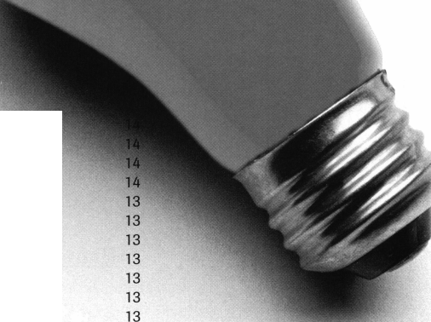

**m a r k e t p** I a o e.

Control Item Access

Key Systems, Inc. introduces the Electronic Utility Cabinet created to simplify storage, heighten security, and control assets.

The Electronic Utility Cabinet is an expanded form of Key Systems’ current Security Key Dispenser, a highly net- workable key control system.

The utility cabinet is a wall- mountable,completely secure system ranging in size and capacity. Secure locks entrap facility master keys, knives, small tools or other items. A simple PIN entry, card swipe, and/or biometric read will provide access to the system.

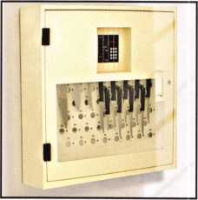

Windows-based software used with the cabinet acts as an ever-present key mon­itor, releasing designated keys during set time periods and recording all trans­actions.

The unit is networkable and can be accessed from any distance. The cus­tomer has complete control of the sys­tem from the customized programming to the sealing of each key ring. The patented Tamper Proof Key Ring

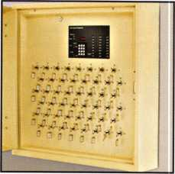

i

|  |  |
| --- | --- |
| | Keynotes | April 2001 |
| L |  |

attached to each stored item allows agility while in use and in storage. Serialized rings eliminate undetected key removal.

Uses include item storage at casinos, universities, zoos, government facili­ties, transit authorities, large and small businesses, and prisons throughout the world.

Key Systems, Inc. is located in Western New York and has been in business for 14 years. All manufactured products are geared toward the security, manage­ment, organization, and storage of keys. For more product information and a list of dis­tributors go to imvw.keystorage.com or contact your local BEST Access Systems or Abloy repre­sentative.

ProtekDoor

ProtekDoor is a new shock absorbing lock and is prsented as a twist on a device much older than amousetrap.The

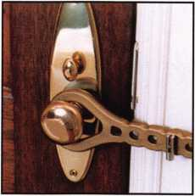

intruder usually operates with the understanding that one swift kick is suf­ficient to over load traditional doo locking hardware that is not painstak­ingly reinforced. Unfortunately, most security hardware is dependent upon the door frame, door trim and inade­quate anchoring screws. Consequently, any significant blow to the door is tran- ferred to the locking components and relatively weak parts of the door that are holding them in place. Then, the frame and trim shatter, the anchoring

screws dislodge and/or the metal locks break. The result: unwanted visitors have immediate access to you and/or your home, allowing no time to react. Short of barricading the doors every night, the inventors of ProtektDoor meant to construct a lock out of a mate­rial that could stretch to absorb those

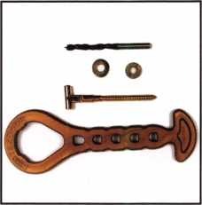

impact forces and anchor it to the struc­tural framing of the door so it would not break loose.

ProtekDoor is designed to be easy to

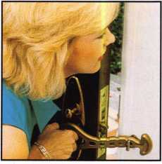

install, simple to use and extremely effective. Compared to the cost of pro­fessional installation of most locks or the cost of an alarm, the security pro­vided by ProtekDoor is a bargain at less

than $20s. ProtekDoor is available on the Internet at tmvw.protekdoor.com and is begin­ning to arrive in stores.

Tiny Trine

Trine Access Technology has intro­duced the new 3234 strike, which con­tains the features of larger strikes in a compact 1-11/16” X 1” overall strike body. In addition to 1200 pounds of holding force, it features the smallest backset (1”) in the industry, stainless

steel latch and locking mechanism, and will accept 1/2” latchbolts. It also meets ANSI standards. This strike is recommended for wood applications.

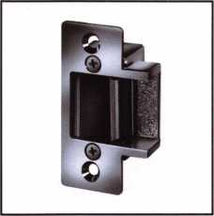

Complete information is available from Trine by calling their Bronx, NY, headquarters at 718/829-2332, or by e-mailing them [custom- erservice@trineonline.com](mailto:custom-erservice@trineonline.com).

V enmark  
International

A full line of adjustable nylon cable ties that feature a 316 stainless lock­ing pawl to create a secure bundle is being introduced by Massachusetts- based NELCO Products, Inc.

NELCO SuperStrong cable ties are molded from UV-resistant black nylon and feature corrosion resistant cable in a variety of sizes and are well-suit­ed for outdoor applications. Available in loop tensile strengths ranging from 18 to 120 pounds, these cables exceed MIL-S-23190E specifications, and are

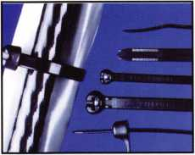

priced from $.02 each, depending on size and quantity. For more information, contact NELCO at 800/346-3526, or visit them on the Web at ivimv.nelcoprodticts.com.

CyberLock is an

electronic cylinder that  
replaces 6-pin mechanical  
cylinders in knob sets, lever locks,

rim locks, mortise locks, and padlocks.

**CyberLock™ Cylinder**

**Convert Mechanical Locks to an Intelligent Access Control System**

|  |  |  |  |  |
| --- | --- | --- | --- | --- |
|  | Key Name | Lock Name | Date/Time | Status |
| ± | Joe Wilson | East Entrance | 03/20/2000 06:14:22 AM | Denied |
|  | Abby Chaney | West Entrance | 03/20/2000 07:28:03 AM | Key Authorized |
|  | Pete Sussman | Records Room | 03/20/2000 07:59:15 AM | Out of Schedule |
|  | John Michaels | Computer Room | 03/20/2000 08:00:03 AM | Key Authorized |
|  | Evelyn Lefler | West Entrance | 03/20/2000 08:12:16 AM | Key Authorized |
|  | Juanita Banks | Computer Room | 03/20/2000 08:18:52 AM | Key Authorized |
|  | Andy Dunsmore | Computer Room | 03/20/2000 08:27:12 AM | Denied |

An audit trail is recorded in both the CyberLock cylinder and the CyberKey™. Call today to learn how easy it is to upgrade to an intelligent access control system!

1105 N.E. Circle Blvd., Corvallis, OR 97330 541-758-0521 **•** Fax 541-752-5285 [www.videx.com](http://www.videx.com)



***April 2001***

***Keynotes***

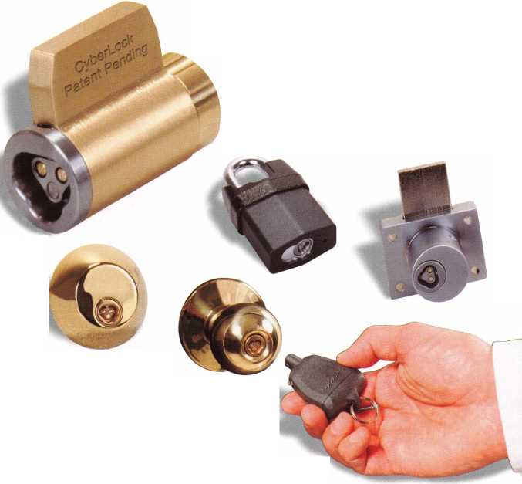

for

**membership**

|  |  |  |
| --- | --- | --- |
| AL | Auburn Universitv  James R Duncan  McCalla | MT |
|  | Brandon K Crowson | NC |
| AZ | Phoenix  Frank E Hester |  |
| CA | Ontario  Scott C Denton |  |
|  | Paramount  David T Moody  San Diego | NM |
|  | Norman  San lose  Jeff S Sanchez | NV |
| GA | Marietta  Jeffrey A Van Every  Riverdale | NY |
|  | Richard K Borden | OH |
| IA | Ottumwa  Mark |  |
| IL | Palos Hills  Adam W Wiewiora |  |
|  | Peoria Heights  Jim K Holmes | OR |
| IN | Indianapolis  Otis L Griffin Sr lasonville  Zane L Twomey | PA |
| KY | Glasgow  Douglas L Lloyd  Lexington | PR |
|  | Brooke P Berry | SC |
| MD | Westminster |  |
|  | John B Wright | TN |
| Ml | Farmington Hills  Michael F McMahon Kalamazoo  Robert F Hughes | TX |
| MN | Savage  Paul F Jorgenson |  |

|  |  |
| --- | --- |
| Butte  William S White |  |
| Knightdale  Olisha S Cox |  |
| Matthews  William J Page  Pinehurst  James H Aldridge | VA |
| Angel Fire  Kevin M McNeely |  |
| Las Vegas  Jeff L Davis  Robert J Leos |  |
| Bronx  Zvi | WA |
| Minerva  Curtis L Kramer  New Middletown  James R Querin | Wl |
| Union  Randall | Japan |
| Portland  Paul R Shiprack |  |
| Savlorsburg  Peter J Romeo  Wayne  Chandler D Evans | Korea |
| Guavnabo  Ricardo J Font |  |
| Hilton Head Island  Bill J Wamke |  |
| Cottontown  Brian D Walter Jr  Martin  Andy  Amarillo  Steve  Austin  David D Nellis  Bret A Hyder |  |



***Keynotes***

***April 2001***

John

**Dallas**

Joel

Alex

Olney

Ernest B Curley

**Alexandria**James L Dunlap  
**Arlington**Lionel E Francis  
Angelo L Kelly  
**Charlottesville**A Dale

Emmett C Dudley Jr  
**Leesburg**

Aaron B Greenburg  
**Manassas Park**Bernard H Doerr

**Vancouver**EricJ Anderson

**Kenosha**

Allen R Abrahamson

**Yokohama-City Kanagaw** Shuuiti

**Go Yang-Si Kvung Ki-Do**Byung-Sun

**Po Hang-Si Kvungbuk**Kwang-Taek

**Pochen-Goon Kvung Ki-d**Sung-Bae

**Sachen-Si Kveong Nam**

Kyeong-Soo

**Seo Cho-Ku Seoul**

Kye-Chul

**Song Pa-Ku Seoul**

Jin-Mu

**Su Won-Si Kvung Ki-Do**

Young-Whan

**Yang San-Si Kvung Nam**

Dong-Kuk

***MAG***

Seeunty

We would  
like to thank all  
the locksmiths who  
have supported  
us for the past  
32 years.

The Original

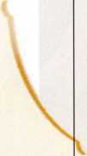

We are also  
announcing the most  
extensive product  
expansion in our  
companies history —  
over 500 new  
products in existing  
and new product

categories.

#

Stop by and see  
us at ALOA.

MAG Security • 15381 Assembly Lane • Huntington Beach■ CA 92649 • Toll Free: (800) 624-9942 (outside CA) • Tel: (714) 891-5100 • Fax: (714) 892-6845 • E-Mail: [mageng@mindspring.com](mailto:mageng@mindspring.com) • [www.magsecurity.com](http://www.magsecurity.com)

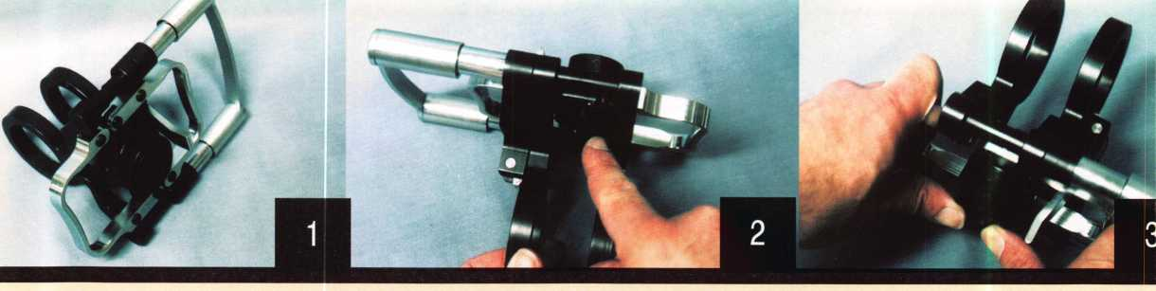

By Sal Dulcamara, CML

16| ***Keynotes***

***April 2001***

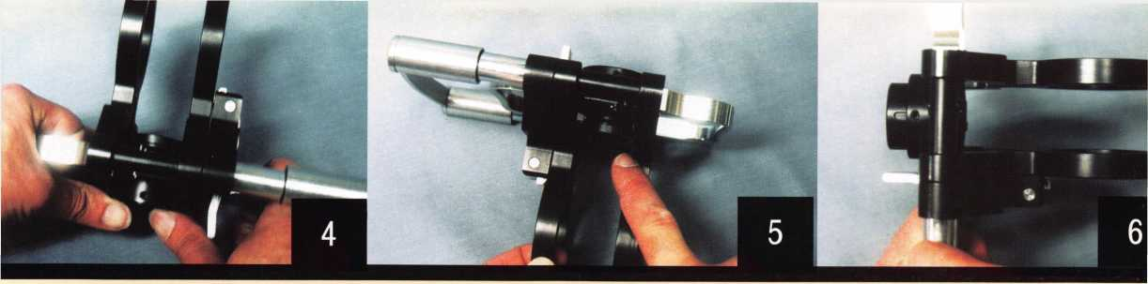

T

he institutional locksmith doesn’t often deal  
with the diversity in lock types and brands  
that a locksmith who advertises his services to  
the public. The locksmith for a hospital or  
high rise commercial building doesn’t typi-

cally get called out to fit car keys or change the locks on a house  
because of a divorce or breakup. An institutional locksmith will  
often be responsible for the maintenance of a master key system,  
and the requisite repairs and installations for the brand and type  
of locks that make up that system. The diversity that he lacks  
in types and brands of locks, he will often make up in diversity  
of non-lock door hardware and door servicing. Depending on  
how tightly his job description is defined, the institutional  
locksmith might also be part carpenter and handyman, too.  
Regardless of the specifics of his responsibilities, a seemingly  
endless schedule can always benefit from tools that make the job  
faster and easier.

Lock installations can be a substantial part of an insti­tutional locksmith’s repertoire, or (for that matter) any other locksmith. Tool setup time can be a major consideration when you are figuring how many locks you will install in a specific period of time. Some of the more traditional installation jigs will often require a few minutes of fiddling with adjustment screws of one sort or another to account for door thickness. Changing the backset will sometimes require accessories and/or maneuvering parts about with a screwdriver or some other tool. Locktools.com has introduced a revolutionary twist to lock installation tools with its introduction of the Wild Jig, shown in photograph 1. Where many tools take minutes to change settings, the Wild Jig can change in seconds. When attaching your jig to a door, you can often go through a myriad of minor

screw adjustments to account for the door thickness, but also to be sure that your jig is attached securely to the door. The Wild Jig accomplishes that almost instantaneously.

Backset Adjustment

Like many installation jigs, the Wild Jig, is designed for lock installations requiring a 1 inch diameter edge bore hole and a 2 1/8 inch diameter crossbore hole. Also like most, it will work with two standard backsets: 2 3/8 inch and 2 3/4 inch. In photograph 2, I am pointing to the interior surface of the edge bore guide tube. When the jig is slipped onto a door, that sur­face will stop the jig and set the backset depth. The center tube, with a 1 inch inside diameter, is the actual guide for the 1 inch diameter hole saw (or other same sized cutting instru­ment) that will create the edge bore hole. With a spring catch type mechanism, the inner tube can be shifted inward or out­ward within an outer tube to change the backset from one posi­tion to the other. At this point, it is set at a 2 3/4 inch backset.

To move the guide tube (and change the backset), hold the jig as in photograph 3, so that you can position your thumbs to firmly press against the tube. It won’t take a Herculean effort to move the tube, but it will move easier if you use both thumbs. With a bit of effort and after about a second or so, pho­tograph 4 shows the guide tube shifted inward. The backset has been reset to 2 3/8 inch that quickly. I am pointing to the interior surface of the guide tube in photograph 5, where it moved 3/8 of an inch. To switch the backset from 2 3/8 inch (as it is currently set) to 2 3/4 inch, you could push outward onto that interior tube surface until it clicks into place.

Backset adjustment, on many popular installation jigs, requires unscrewing a part or parts in order reposition them. Some can be unscrewed and adjusted by hand without any tools,

***April 2001***

***Keynotes*** | 17

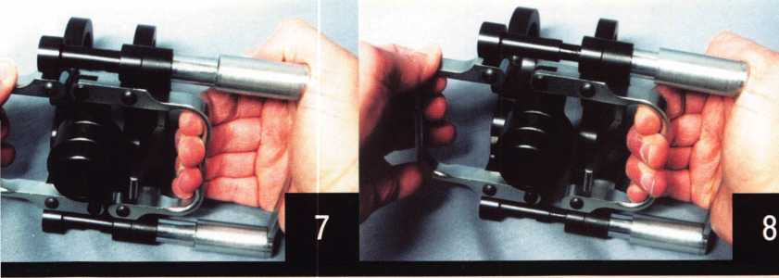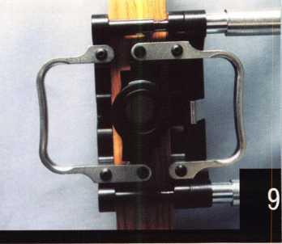

while others will require a screwdriver or some other tool to undo the screws. While the backset adjustment will not add hours to the overall length of a job, a couple of minutes here and there can add up when quite a few locks need to be installed in a limited time frame.

Door Thickness and Jig Mounting

According to the product literature, the Wild Jig is designed for use on doors ranging from 1 1/4 to 2 1/4 inches thick (whether metal or wood). The gap that you see between the inner and outer faces, in photograph 6, is the normal narrow gap position that is created by the spring action between the two parallel faces. When I slipped the jig over a 1 3/8 inch thick door, I didn’t detect a firm grip until I engaged the lock­ing lever. I’m not sure how tight the grip might be on a 1 1/4 inch thick door. I’ve personally never run into a door that thin.

Photograph 7 shows a door edge view perspective (if the jig had been attached to a door) of the Wild Jig. It is still in its narrowest door thickness setting, with the inner and outer jig faces as close as the spring action alone will take them. In the photo, I have my right hand positioned where it might be if I was to spread the jig faces against the spring action of the tool. The palm of my right hand is positioned along the right side of the frame, while my finger tips are hooked around a grip­per surface where I would have to pull. As I pull my finger tips toward my palm, in photograph 8, the space between the paral­lel faces of the tool expands. The edge bore hole guide auto­matically self centers, regardless of how far it is spread apart.

The jig has been slipped over the door edge (of the lock mount), in photograph 9. You will need to create a sufficient

gap against the spring pressure, so you don’t scrape the door faces as you place the jig on the door. When it is positioned to its stop surface, releasing the gripper handles will cause the spring action to hold the jig firmly to the door. A view of the locking lever (in the unlocked position) is shown in photograph 10. The spring action of the tool alone will keep the jig from falling off, but drilling could cause the jig to shift if it is not locked in place first. The torque of a spinning hole saw is not to be taken lightly.

The locking lever is moved all the way to the right, in photograph 11, so the jig is locked securely onto the door for drilling. When locking the lever, do not stop pressing until it touches the surface of the metal gripper and can move no fur­ther. That way you will know that it is locked tightly on the door and shouldn’t shift during drilling.

I am right handed, so I handled the tool in such a way that any gripping strength needed would accrue to my right hand. The Wild Jig can be flipped around for a left handed installer so that all the working movements are on the opposite side and can be easily accessed with one’s left hand instead. The jig can actually be positioned and set one handed, but you prob­ably gain a little better balance by using both hands.

Photograph 12 shows an angled side view of the jig with a 2 1/8 inch diameter cross bore hole drilled through the lock mount. It is recommended (as with many other jigs) to drill inward from both the inside and outside surfaces of the door, rather than drilling all the way through from one side. Drilling from one side will often cause splintering on wood doors or burrs on metal doors. You will also have a greater ten-

18 | ***Keynotes***

***April 2001***

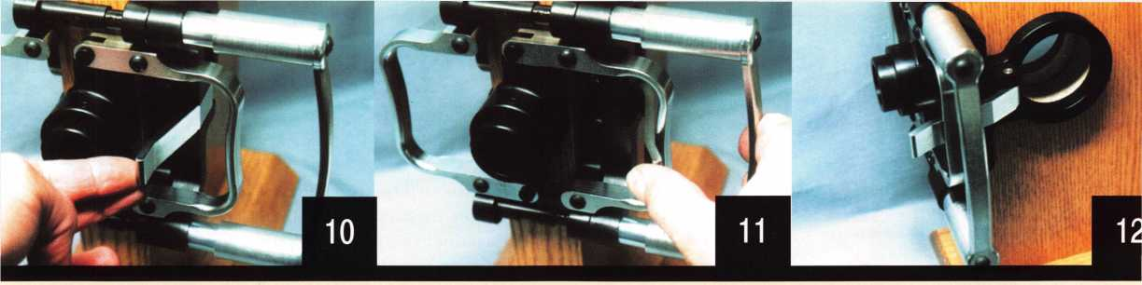

dency to wander off center without the circular opening of the jig to guide your cutter. The hole drilled here (along with the jig setting) is 2 3/4 inch backset. When you are sliding the jig onto the door, the edge bore guide hole tube will act as a stop to set the 2 3/4 inch backset. Actually, you could press the jig onto the door with considerable force against the edge of the door and you wouldn’t change the setting of the 2 3/4 inch backset. If you had the Wild Jig set for 2 3/8 inch backset, applying a great deal of force against the edge of the door could shift the guide tube outward and change the backset to 2 3/4 inch. You would probably hear and feel a click as the spring catch reset, but you would also see visual indicator of the nar­rower inner tube sticking out from the guide hole edge of the

jig-

I must say that Gene Fridman of Locktools.com has done some interesting things to change the operation and feel of installation jigs. I think that many locksmiths will find them a lot easier (and faster) to use than the more traditionally designed jigs. For more information on the Wild Jig and other innova­tive tools, contact: Locktools.com, 60 North Winchester Blvd., Suite 4, Santa Clara, CA 95050. Phone: 408/979-0337. FAX: 408/723-3377. You can find them on the internet at (where else): [www.locktools.com](http://www.locktools.com)

Tech Article Addendum

I’ve been writing for locksmith publications for some­thing over 15 years, and until recently I’ve resisted having some kind of presence on the internet. I recently put together an “amateur” website, which still has more to be done to meet my

personal standards. In the mean time, though, I would like to use it as a way to help readers of my articles get information cor­rected or clarified quicker. Rather than waiting for an editor’s note two months following that a phone number or address that I listed was incorrect, I will try to post the corrected informa­tion on the website. If photo 1 and 2 were switched, it will make more sense when reading the article if you know what pic­ture to look at. You should be able to find the Lockwriter Home Page at <http://home.earthlink.net/~lockwriter>. At the bottom of the home page, you should see a page link to “Tech Article Addendum”. That is where I expect to put updates and correc­tions to my various technical articles. Web page creation is completely new to me, so I hope to gradually improve the qual­ity and value of the website as I gain more experience and pro­ficiency. This is a free site and not restricted access, so I will not put anything of a sensitive nature on the site. E-mail and other methods of contact will be on the website, for information not publishable on the website.

***April 2001***

***Keynotes*** | 19

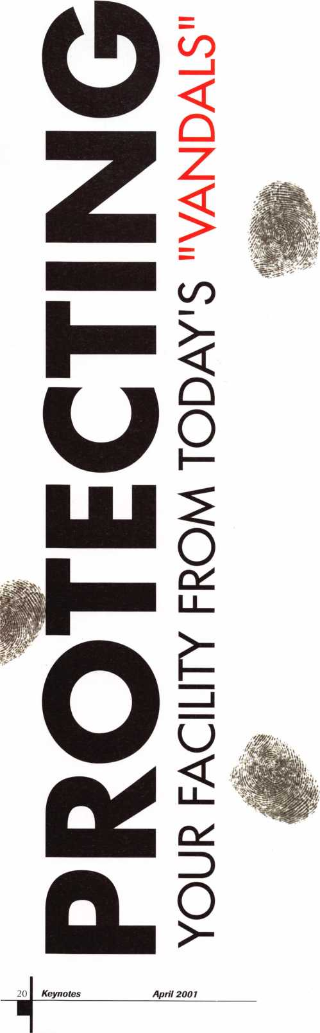

By Denise M. Lopez, CRL Security Hardware, Inc

Protecting your facility has never been more important than it is now. Gone are the days when vandalism meant mischief by a few bored schoolchildren. With computers and high tech business machinery, today’s vandalism can result in a million-dollar loss in less time than it takes to drink a cup of coffee. With that in mind, in the eyes of the facility administrators, our role as locksmiths has gone beyond the stereotypical installer/blue collar worker to that of a security professional. They may have hired a so-called security consultant to tell them where the concerns are, but who knows bet­ter than we do how the hardware actually performs in real life?

Assess the Current Security Program

Before rushing into a new security program, you must first make an assessment of the existing one. This will set you apart from those who came before you, or from your competitors in the marketplace. When the administrators of the facility ask for your suggestions, begin by identifying the area of concern. Ask the questions. You don’t want to spend hours developing a plan only to discover they wanted something else. What are the security concerns of the facil­ity? Is this a defense contractor where vandalism can result in loss of multi-million dollar contracts? Is this a school where hard-to- get computer equipment needs to be protected or the safety of the schoolchildren is a top priority? Maybe this is a business who is concerned about disgruntled workers. Is abuse or vandalism occur­ring now? What is the relevant history of the facility? Summarize the current situation before proceeding to recommending the solu­tion.

Typically, a physical attack will target exterior openings, although in some instances it will involve an “inside” person, and the target will be an interior room. Key system compromise is one of the most overlooked (by administrators) problems on a facility. How many times have we, as locksmiths and the “keepers of the keys” preached about lost keys, only to have our supervision shrug and say, “Oh well, make them another one”. Lost keys, unauthorized duplication, uncontrolled crosskeying and worn cylinders all work against keeping the facility secure. Key system compromise can lead to employee theft, taking place during an after hours “return” and resulting in thousands of dollars lost.

What do the codes say? They differ from door to door and region to region. Our job as security professionals is to wade through the bureaucracy and come up with an answer.

School security, unfortunately, has entered a new era. No longer is it enough to secure the doors from vandalism, but it is now para­mount to protect our children from the violence that has exploded in recent time. Classroom lockdowns have become a focus of school boards and local governments. Today every school either has a lock- down policy or is working on one. With our knowledge of hard­ware and what will work, we have the ability to offer real world solutions to this tragic problem.

So, how do we recommend a strategy? There are four steps to rec­ommending solutions: Assess the existing security policy; identify the area of concern; examine the opening; and develop the plan.

Examine the Opening

What makes up the opening? There are three basic components that our profession is concerned with - Doors, Frames and Hardware.

Doors come in many types and sizes. Is the door wood, hollow metal, aluminum storefront, or FRP (Fiberglass Reinforced Polyester)? If wood, is it solid core or hollow core? Is the hollow metal reinforced? What gauge metal is it? What condition is the aluminum door in? Has the locking method been changed so often it looks like Swiss cheese?

One type of door developed for vandal resistance is the FRP door. It is constructed of high density foam surrounded by Fiberglass Reinforced Polyester sheets on the face of the door. Door edges are protected by edge guards and the door is hung by a continu­ous hinge. Manufacturers for these doors include Extrudart, Specialite, and Chem-Pruf. The FRP sheets have a pebble texture finish and are virtually maintenance free. The colors do not fade or chip, so the door never has to be repainted, and is highly resist­ant to graffiti.

When looking forfeitures on a door, look for full width top, bot­tom and mid^mls. Some FRP manufacturers only supply these as a custom order, but these should be included on each door. Aside from offering a door function change from a lock to an exit device, the full width rails add the strength you are looking for when try­ing to combat vandalism. Since these doors represent an invest­ment, it pays to be prepared. Look for full-length pin and barrel hinges, preferably one that is adjustable. The Extrudart door can be adjusted to “fit” the frame in the field, an important feature since we all know how square the frames are out there.

Look at the frames. Have they been attacked so many times that there is little for the latch or bolt to grab? Maybe they need to be replaced or reinforced. It will not do much for the opening to change hardware or the door, yet leave nothing for the securing mechanism to hold onto. The “Jamb Jacket” by Major Manufacturing is an excellent solution for a frame in need of rein­forcement.

Then there is the hardware (our favorite part). What type of hard­ware is existing? It never ceases to amaze me that we, as a socie­ty, make our greatest investment in our homes or businesses, then install the cheapest lock we can find. How can we expect a three- dollar lock to secure our families or our livelihood?

Grade 1 vs. Grade 2

We hear a lot about Grade 1 or Grade 2 hardware, but what does it mean? Does it really make a difference?

Grading of hardware is done by ANSI - the American National Standards Institute and BHMA, Builders Hardware Manufacturers Association. The grades are many times referred to as cycle testing, although they are considerably more involved than just that. They involve latchbolt projection, knob/lever, rose/escutcheon tests, torque tests, bolt strength, as well as how many times the hardware must cycle. For example, to be desig­nated as Grade 1, a cylindrical lock must test to 800,000 cycles without failing. For Grade 2, the numbers drop to 400,000.



In additional to Operational Grade 1, there is a Security Grade 1. The testing for this adds impact and strength tests. For obvious reasons, if one is looking for a strong lock, look for the Security Grade 1 label. The locks are out there. Corbin Russwin’s ML2000 series, Yales SL8700 series and Sargents 8200 series all meet Security Grade 1 right out of the box. The Schlage L series meets Grade I Security, but according to their literature, only with the concealed cylinder option.

When looking for Vandal Resistance, stay with Grade 1 hard­ware. It is best for all exterior applications, as well as interior doors with high usage or abusive environments. For economics, you can supply Grade 2, but only in areas that are medium-low usage, supervised and non-abusive, such as the interior offices of a suite.

Develop The Plan

What does your facility have now? Where does the management want to go? And how do we get there from here? Create the plan in an orderly fashion. Use the components of the opening to determine how you need to progress: hanging, securing, control­ling and protecting the door.

Hang the Door

This is usually the most overlooked part of the opening. Many security issues arise from hinge failure. Hinges fail either from improper hinge selection or age. If the hinge fails, the door won’t secure, and we get a call saying “the lock is broken.” The lock is blamed for most security failures when it is really another com­ponent of the opening.

There are four methods of hanging a door - Butt Hinges, Continuous Hinges, Pivots, and Floor Closers. When using butt hinges, look at the information provided by the manufacturer. Should you use standard weight or heavy weight? The size of the hinge is important. By the way hinges are stocked, one would think there are no hinges besides a 4-1/2x4-1/2. But remember, size is important. The number of hinges is important as well. If you have an 8’ single door, you need to have 4 hinges on that opening. If this is an exterior outswing door, you NEED non­removable pins. Or consider adding Jamb Pins, which are replacements for hinge screws. Adding these will prevent the door from being removed when in the closed position. Base metal and finish are important. Exterior doors should have bronze or stainless steel for base metal. Base metals of plain steel will rust and the hinge will fail. This means you need to order 626 on an exterior door, but 652 for a fire door (steel base with brushed chrome). Of course you might want to consider 630, stainless steel if you have a moisture problem and avoid any rust problems. Anchor hinges and reinforcing pivots can be added, but remem­ber this adds to the cost of prepping a door. It’s best to get it right the first time.

The advantages of butt hinges are cost and availability, but the down side is that the screws are always in tension. The top hinge carries the brunt of the work, and will eventually wear and the door will sag. So what’s an alternative? Continuous Hinges.

***April 2001Keynotes*** | 21

Continuous hinges are a more efficient means of hanging a door. The hinge dissipates weight along the full door height. This reduces sag and stress at the top of the door. Continuous hinges also protect the door edge, and when incorporated with a hinge guard and edge guard, you can essentially “wrap” the door and prevent abuse on the edges. This is especially important if your facility uses carts, gurneys, etc. to move people and equipment. There are two major types of continuous hinges - pin and barrel, and geared. Geared hinges are not recommended because of the grit that can accumulate in the gears, (or substances inserted by the little darlings at the school). The best material is by far the stainless steel hinge, such as is offered by Markar Products or Stanley. Look for warranties, special layouts, models that address the multitude of door/frame conditions, ease of installation, and quick ship programs to help determine which hinge to select.

By far the most efficient means to hang a door is a pivot or floor closer. The weight of the door is directly on the bottom pivot/closer. The screws are in shear, not tension. I realize there is a trend to replace floor closers with surface closers, but look at how long the closer has been in there. Usually it is 25-35 years. You may have to replace a surface closer every 5-10 years. If you replace the floor closer with another floor closer, you won’t have to return to that opening for the rest of your career!

Secure the Door

There are many methods to secure the door: Locksets, both mor­tise and cylindrical, Exit Devices, Deadbolts, and Access Control locks are just a few of these methods.

Mortise locksets are generally recognized as the most secure, as a deadbolt can be incorporated into the lock while maintaining the single motion egress requirement. As previously discussed, a Security Grade 1 option can be added, enhancing the lock. Outside trim can also play a major role. Special vandal resistant trim is offered either as an outside pull (used with latch holdback feature) or a lever trim that always remains attached to the lock- set, even if broken. When incorporated with a heavy duty lock, the combination can’t be beat. The Trimco pull is widespread on the West Coast because most classrooms have exterior doors and the weather is mild. The lock is held in a holdback mode during the day, and acts like a push/pull. Removing the lever from the outside of the door has dramatically reduced vandalism for many school districts.

Many manufacturers now offer a freewheeling or clutched lever on their cylindrical locks. This feature offered by Yale, Corbin Russwin, Sargent, and as an option by Schlage, has proven to be effective in the war against lever breakage.

Be aware of new functions offered by top manufacturers. School security series mortise locks offer a solution to the lockdown pro­cedure at many schools. The classroom function can be locked down from the inside of the classroom in the event of an emer­gency. Sargent, Schlage, and Corbin Russwin all have special fea­ture mortise locks designed for school lockdowns. Be sure to

check functionality - on some locks, if someone exits after the lockdown, the door is no longer secure. Look for the function that remains locked after egress. If there is an emergency, and you need to let one more person in, you want the door to be locked when it closes.

Exit devices are becoming more prevalent as a means of deterring vandalism. Required when occupancy is 100 or more, or in areas of high hazard, they are now showing up on classroom doors and smaller facilities. This is due to the strength and durability of the devices. A rim device, by far the most secure, can incorporate heavy duty trim to protect against abuse. When securing pairs of doors, the most secure method is to use two rim devices and a mullion - and don’t forget the mullion stabilizers! Yale and Corbin Russwin also have a patented deadbolt style security latchbolt as an option for their rim devices. Because of the design of the latchbolt, it takes far greater pull than the standard pull- man latch to defeat the device. It is also rated as a Type 28 device by ANSI, which is listed as a security exit device.

Deadbolts

Deadbolts are a sure way to secure the door. But be careful - many areas in the country have prohibited their use. A deadbolt adds a second motion to egress, and Fire Marshalls are very serious about the single motion exit requirement. Before installing a deadbolt in a commercial or public building, make sure it is approved by the local fire officials, or you may be returning to remove it.

Access Control

Access Control locks can also play a major role in deterring loss, particularly employee theft. Units such as Alarm Lock’s T3, Omni lock, and Mas Hamilton retain an audit trail record of entry. Not surprisingly, when an audit trail is added to an area such as a tool crib, tools stop “mysteriously” disappearing. Accountability has added a new dimension to the workplace.

Control the Door

The purpose of a door closer is to control the opening and closing cycle of the door. Mechanics of the closer relating to vandalism issues are backcheck and latch speed, and optional stop features. Besides being the most efficient means to hang a door, a floor clos­er is the most efficient means to close it. Rixson offers a dead stop feature in their heavy duty closers. The door will simply not trav­el past this dead stop. This eliminates the need for floor stops, which can be a trip hazard.

Surface closers offer heavy duty parallel arms, arms with stops incorporated in them, spring cushion/stop application. Remember that even if there is a stop in the arm, rarely is this suf­ficient to be depended upon to fully stop the door. There is no substitute for a floor stop, wall stop or overhead stop to prevent overtravel and blowing out the closer.

Covers can be secured to the closer with tamper resistant fasten­

***Apri12001***

***Keynotes***

ers. In some cases, you may need to step up to a security closer, specially designed for abusive environments.

Door Stops

Door stops prevent slamming the door into walls and equipment. They will save the door. Overhead stops and holders will prevent “racking” the door, and provide a positive method of stopping the door when floor or wall stops are not feasible. There are specially designed floor stops such as the 1209 stop by Trimco that fea­tures a large vandal resistant rubber stop that is installed into the cement. The products are out there.

Coordinators

Often overlooked or not in working condition, the coordinator is essential to control the sequence of the closing of pairs of doors. It will prevent doors from sitting ajar should the active leaf close before the inactive leaf. It is absolutely essential when an over­lapping astragal is used. They are of three types: Surface bar, such as the DCI 600 series, the gravity type, such as the Glynn Johnson, or one that is incorporated in the floor closer, such as is offered by Rixson.

Protect the Door

Pulls are becoming a popular method of vandal resistance. Removing the lever (aka the “target”) reduces vandalism to a much lower level at many facilities.

Protection plates, such as kick plates, door edges and the like will save abuse on the door for many years. Be aware, however, that the height of kick plates on labeled openings is spelled out by the local fire authorities. Don’t get caught putting a 48” high armor plate on a fire door without approval - you’ll be back to take it off. Astragals - full length, lock astragals, security astragals - all play a part in keeping the lock secure. Outswing doors should have a latchguard to prevent unauthorized entry.

Don’t forget Weather seal and door bottoms. If in an abusive environment, peel and stick weatherstrip might not be a good idea. Perhaps a jamb applied seal is in order, and in truly chal­lenging areas you might consider tamper resistant screws for installation. But don’t go without it. Sealing the door is just as important as securing it. Energy codes and water damage are very real issues that need to be addressed in the overall Plan. Security door bottoms are available from Pemko and other weatherseal manufacturers. They provide a security bar that drops down when the door is closed, preventing the use of “under the door” opening tools to defeat the lock.

For the same reasons as above (water damage and under door tools) check the thresholds. Fixing a door with new hardware, paint, and security items, and leaving the threshold in a state of disarray is like wearing a new suit with holey shoes.

Summary

Provide a summary with your plan. State the available options, with alternative strategies. List the advantages and disadvantages of each. State projected cost estimate of each option. Give the administrators three options: Minimum - What will get them up and running; Primary - Add “The Plan” for Vandal Resistance; Visionary - Look to the future.

Always make a recommendation. Recommend one or more of the strategies, summarize the results if things go as proposed, identi­fy what needs to be done next, and above all, follow up! Recognize that administrators have many issues before them. Take the ini­tiative to follow up and see how the program is being considered. A no today may be a yes tomorrow, or when next year’s budget is being planned. Find out what the fiscal year is and when budget proposals are submitted. Remain vigilant.

Remember, you are the professional.

ALOA Bookstore Titles

l.Safe Deposit Depth and Space Manual Author: John Cannon, CML

Includes key cutting dimensions and important other notes of information for over 100 types of safe deposit locks including those manufactured by Bates, Carey, Diebold, Eagle, Invincible, Isham, Kumihara (Security), LeFebure, Miles Osborn,

Mosler, National Cabinet Lock, P.P.I. (Ilco), Remington & Sherman, Sargent & Greenleaf, Victor, Western, and Yale.

List Price: $99.00 + shipping

2.12 Safe Deposit Code Cards for 1200 CM

These cards will allow you to originate keys for most of the safe deposit locks that are in service.

List Price: $90.00 + shipping

3.Safe Deposit adapter kit for use with the Safe Deposit Depth and Space Manual and the HPC 1200CM

These adapters will allow you to use the depth and space indications without having to "bump the cutter" saving time and improving accuracy List Price: $75.00+ shipping

4.Direct Entry System Manipulation Kit John Cannon/Mike Oehlert

The kit includes: a manual which details the inner workings of a wide variety of antique and modern direct entry safe locks as well as providing the step by step proce­dure for manipulation of this type of safe lock, a magnetic scale, pointers with mount­ing hardware and other items that will assist in opening these safes in a very short time.

List Price $99.00+ shipping

5.Safe Technicians Reference ManualAuthor: Mike Oehlert, CPS,CPL This reference manual belongs in every safe technicians library. You will find clear illustrations and detailed information on start-up equipment needs, how, when & where to drill, drill point options, lock handing, lock parts identification, combination changing, relock triggers and devices, construction ratings and more. This manual is used as the class text for the new Certified Professional SafeTech Preparation Course. List Price $135.00



*AUTOMOTIVE*



i I e m m a



By

Tom Seroogy

B

y now, most locksmiths are as tired of hearing how much they’re losing by not working on  
transponder vehicles, as they are in hearing how much it is going to cost to purchase the  
transponder equipment needed to do the work.

Well, don’t fret. Just remember that outside of all the hoopla, there’s really only one way to determine whether transponder work is the right choice for your business. You need to seriously ask, what does it mean to the bottom line?

That’s right, no matter how sensible a smooth talking salesman can make it sound, if purchasing a piece of equipment (transponder or otherwise) doesn’t put money into your pocket, it’s probably not worth buying that piece of equipment nor doing that type of work.

Here are a few guidelines when considering transponder equipment:

Keynotes

***April 2001***

1. Study your demographics.

Don’t buy a tool because you lost a call! With **the cost**

of transponder tools being so

fTaetermining the

‘real” need for the tooj^i^essential. Knowing how hard

it is to turn doyrti any job, it’s important to determine  
whether **y**dur market can support a locksmith doing  
transponder work. When making this determination,  
tyo facets should be considered - current transponder  
'business and potential transponder business.

Your current transponder business is best measured by  
the amount of requests you encountered over a given  
amount of time. If transponder work is currently not a  
part of your business, these requests can be easily  
recorded and tabulated for determining “lost income”  
due to not accepting this type of work.

Still, determining what you may currently be losing is  
not quite the whole picture. There is still that question

is that the tool is viewed as an expense and not an  
**^invest**ment. While this may seem minor, the eventual

latic.

research demands a little more investigative work, there are a few factors that are indicators of high transponder potential:

1. If you’re currently performing work for franchise and independent auto dealers.

>. If you’re currently performing work for roadside ^tance groups.

c. it y(3*t re in an area of high tourist traffic.

1. A tool phtchase should be viewed as an investment not an expense.

One of the largest miscohs^ptions in purchasing tools

outcome can

As an expense, a tool is^Nqecessary evil; purchased  
because it has to be purchased. concern is given

to its impact on the overall operation ariHuprofitability  
of the company. Often the tool is purchased out of an  
immediate need that may or may not be profitably in

the long run.

When viewed as an investment, however, a tool is pur-  
chased with the expectation that the money invested  
today will yield a return over a given amount of time.  
Its expected impact on the company is measurable and  
exact. If a return is not expected or is not realized, the  
tool is either not purchased, or sold for a more prof-  
itable tool.

Of course, how long it takes to make your return on a  
tool investment may vary, and is dependent on the

For some, it may take  
^“^^**^^^^**^^^^^**^^^**^alized on the purchase of a  
$1995.00 Ford NGS tool. For others, it may only take  
a few months. How long an expected return and profit  
can be realized is an important factor in making the  
decision to purchase a transponder tool.

Another misconception is that transponder equipments  
is indeed, expensive. As an expense, this is most cer-  
tainly the case. As an investment, however, the cost of  
the tool is seen relative to the expected retupd.

For example, the national average cosj^for generating  
brand new keys for a Ford vghfcle equipped with  
transponders runs fromj^TO.OO to $600.00. To make

April 2001

Keynotes

this more competitive, let’s say wijji.iigi1 only |700 Of to make a new ^er'of Ford transponder keys. Considerins^ffie NGS unit costs around $2000.00, it takes/dnly 10 cars to pay for machine.

!!ompare that to the purchase of a new code machine. At $15.00 each for cutting a key cut by code, you would have to cut at least 134 keys before breaking even on a $2000.00 machine.

By all accounts, if your market supports doing a mini­mum of 10 Ford transponder jobs a year, the NGS is not a bad investment.

1. Understand the capabilities of the machine being purchased.

Ever buy a toy only to find that batteries were not included? Transponder equipment can yield the same frustrations if you’re not fully aware of what is neces­sary to produce a key using that equipment. Here are a few things to consider before making that transponder tool investment:

1. Can the tool be easily updated for new model year vehicles?
2. Are PIN numbers required? If yes, are they easily accessible?
3. Is training available?

Following is a list of common transponder tools and some important features of each, si. Ford NGS - $1995.00 MSP. Readily available, read­ilyupdateable. No PIN numbers required. Training and servibsjnanuals available from various resources.

1. Chrysler DART - $1200.00 MSP. Locksmith version readily a^&ii^ble, readily updateable. PIN number is vehicle specific. PINs available to registered DART users through Chrysler Ro&^side Assistance. Problems reported with inability to geK PIN number from Chrysler Roadside Assistance. Can okyiised to program additional Keyless Remote Fobs into Chrysler, Plymouth and Dodge vehicles. (See photograph 2.)
2. Mitsubishi MUTII - $3500.00 MSP. Limited avail­ability, updating difficult. PIN number requiredVnd is model specific. PIN numbers are included with **MIj^TII** purchase. (See photograph 3.)
3. Nissan/Infiniti Consult II - $6500.00 MSP. Limit*! availability, updating difficult. One PIN numbet required (for V5.0 vehicles). PIN number includec with Consult II purchase. (See photograph 4.)
4. Lockmasters VW Tool - $1499.00 MSP. Readily available, readily updated. PIN number is required ancj is module specific. PIN numbers are available fror VW dealers only, and require the retrieval of the veMi- cle’s module serial number. The VW Tool is used to retrieve the serial number from the vehicle’s mdaule. The VW dealer can provide the PIN based on ^ne seri­al number. (See photograph 5.)

For more information on transponders and transponder equipment, or to receive a catalog, contact Lockmasters Inc. at (800) 654-06#/.

(See photograph D)

***Keynotes***

***April 2001***



Probably the most common transponder system sold today is the Ford New

Generation Star or NGS system.

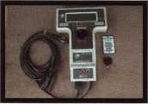

2.

Chrysler requires the DART diagnostic tool as well as a vehicle specific PIN number to program keys.



3.

The MUTII is hard to get but necessary for programming many of today’s Mitsubishis. A model specific PIN number is required for programming. A PIN list is included with the purchase of the MUTII from Lockmasters, Inc.

4.

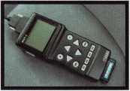

Nissan and Infiniti require the Consult II to perform transponder key tasks.  
Models using V2.0 do not require a PIN code. Models using V3.0 require a PIN  
number. The PIN number is included with the purchase of the Consult from

Lockmasters, Inc.

5.

This new VW Tool from Lockmasters is a cost effective way to program transponder keys for VW and Audi. In order to program new keys, a PIN num­ber is required. The PIN can only be gotten from a VW dealer.

* **OOBOaDQ** tsw
* QQQOOBB 01553

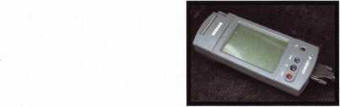

*SPEEDYPLK®*

THE AUTOMATIC  
KEY IDENTIFICATION  
SYSTEM

* Preprogrammed database with full side view
* Automatic inventory control and reorder program
* Create your own database(s) to match your keyboard
* Hire inexperienced personnel without training

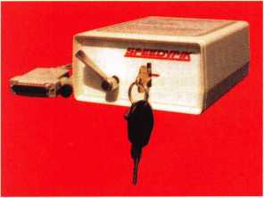

THE AUTOMATIC  
KEY DECODER SYSTEM

* Eliminates measuring each cut in a key
* Eliminates looking in pinning charts
* Portable, hand-held, battery-oper­ated
* Connects to your computer (serial port)
* Complete scan & readout in seconds

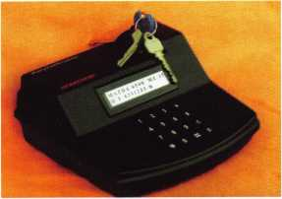

Phone: 617-567-1111  
Fax: 617-277-7777

E-Mail: SPEEDYPIK @  
AOL.COM

[www.SPEEDYPIK.com](http://www.SPEEDYPIK.com)

***April 2001***

Keynotes

YOST

CML, CPS

#

|  |  |  |  |
| --- | --- | --- | --- |
| m | ♦ |  | • |
| 1 |  | # |  |
| m | Keynotes | April 2001 |  |
|  | m | | |

Imagine, if you will, your first day on the job as an institutional locksmith in a university lock shop. The place is clean, there is a new looking key machine, but something is missing, something not quite right. Over the next few weeks, you dis­cover, horrified, there are no key records, no floor plans, no code equipment and none of the techni­cal books and materials needed for a high-quality, professional shop. Worse yet, you learn there is no key control at the University and the whole place is at risk. You have just entered the Twilight Zone!



I

have to tell you right up front, challenges, however  
daunting they may be, can be overcome. It takes per-  
sistence, dedication, more persistence, and a certain  
amount of fearlessness. And time. Plus a lot of

knowledge I did not have when I first started as an insti-  
tutional locksmith for Utah State University. To give you  
some background about me, in 1973, I went into the  
Florida State Employment office in Tampa and saw an ad  
for a locksmith apprentice. It was in a little key shop out-  
side a department store. Within a few weeks, I found I  
loved the work and I had a little talent for locksmithing. A  
year and a half later, I started working at a newly opened  
lock shop and it was great. David Jimenez, the manager,  
was from New York City. He was so knowledgeable, willing  
to teach me anything and I just soaked it all in. In 1977, I  
moved to Utah with my wife and children with the dream  
of starting my own business, which I did that same year.  
Sometimes, things do not work out the way you want them  
to, so by October 1981 I went to work at USU, waiting and  
hoping for an opening in the lock shop. What I was not  
expecting was waiting for 7 _ years. The first work day in  
the lock shop, I remember tearing down a lock, repairing  
it, and getting my hands all covered with grease and dirt.  
I brought my finger tips to my nose and inhaled deeply to  
smell what had become so familiar. I was back home, and  
I loved it!

After starting at USU, it took a few months to dis­cover almost all the master key systems had been cor­rupted: poorly designed extensions and changes; no key records; and a simple lack of knowledge about master key­ing theory. The locks used then on campus included Schlage, Yale, Falcon, and Corbin. Within these brands, there were more them 40 different keyways in use. My first challenge was to develop records for every lock and key in use. I had to reverse engineer all the key systems and assign key codes to every key. Doing this helped me real­ize that I could not salvage any of the key systems. After months of discussion and weeks of training at severed high security lock companies, the University requested bids.

ASSA High Security Locks was selected. Now, I had no idea how much this would cost when I started requesting a major change in the keys. After the bid was awarded in 1990, the ballpark estimate cost of replacing cylinders was $250,000.00. Today, we are about 80% complete, half the keyways are retired and we are rekeying three or four buildings a year, when I can get the funding, though I do try to squeeze in a small building here and there. I can confidently say we have spent more than the original esti­mate, mostly due to the replacement of worn out and obsolete locksets. At first, there was a little resistance from the Facilities administration to invest that amount of money, however they quickly signed on, and had enough confidence in me to let me run the project, for which I am very grateful to my supervisors.

The biggest challenge I personally had was to overcome the lack of key control. It would not matter one bit that we had ASSA keys and cylinders if we did not have key control. To make matters worse, all keys had been stamped with the building and room numbers. Most of you must be aghast, as I was, at the very thought of stamping that information on keys. The very first change I started to make was to stamp the keys with a blind code. Unfortunately, I ran into a brick wall. The University Police had been issuing the keys for the past 4 or 5 years and the then-Police Chief adamantly refused to allow me to change the way keys were stamped, despite the fact this breeched security. I even had my job threatened over this point of contention. Remember persistence and fearlessness? The Police Chief did not realize he was the tail trying to wag the dog. In 1992, USU got a new Police Chief; we see eye to eye. Tensions evaporated and I rapidly progressed with changes. The University now has an effective key control policy, with hook and issue numbers stamped on the keys.

Having no records when I started in February of 1989, I wanted a key records management system that fully integrated information on the keys, locations, hard­ware, history, and key holders. The system needed to have a wide variety of reports, generate pin stacks, audit key holders, and print forms. After looking at the computer

***April 2001***



***Keynotes***

programs available in 1990, it was evident none could do  
everything I wanted. It was time to design my own sys-  
tem. With the help of a student, Jeff Taylor, who was pro-  
ficient in programming, we did it. Even today, I have not  
I seen any program that comes close to being comparable.

Staffing a lock shop is always a difficult proposi-  
tion. Highly qualified people who fit in an institutional  
environment are rare. At a state university where the  
I state’s legislature is known for being very frugal, you can-  
not afford to hire them, anyway. Developing the staff to  
be highly qualified is what we do. At USU, I have 2 full-  
: time employees and 2 student employees. Curtis  
Leishman, my right hand man, started working part-time

in the lock shop in 1988 and full-time  
I since 1996. Brandon Pitcher started  
I working for me this past August.

Having students employees seems to  
I be fairly uncommon. Most universi-  
ties I have visited, from Yale to  
Stanford, do not use any students at  
■ all. An exception is Brigham Young  
I University, where they are heavily  
I dependent on a large student staff to  
; assist their locksmiths. As for our  
| students, Justin Card has worked for  
me nearly 3 years and Nate Petersen  
just started in February. I have had  
l some great students work for me,

j most staying 3 to 4 years. Self-starters, trustworthiness,  
good memory and an attention to detail are the traits  
needed in all employees.

My goals are to teach Curtis and Brandon every- [ thing I know and to get them to classes as often as pos- [ sible. This is where the locksmith associations have the 1 greatest impact with my staff. Classes offered through ALOA and by manufacturers are so essential to the suc- | cess and professionalism of institutional locksmiths. We j: subscribe to the trade journals for the same reason; edu- | cation. I originally joined ALOA in 1978 when I had my j own business. I, unfortunately, let my membership lapse in 1982. I rejoined in 1990 and attended my first ALOA | convention in Chicago, 1991. I am very grateful my boss,

I remember tearing down a lock, repairing it, and getting my hands all cov­ered with grease and dirt. I brought my finger tips to my nose and inhaled deeply to smell what had become so familiar. I was back home, and I loved it!

Scott Goodwin, made it possible for me to attend this and  
many other educational opportunities during my career  
at USU. I certainly lacked knowledge when I started this  
job, but the University made sure I got the education I  
needed. Beginning in 1990, I also joined the Beehive  
State Locksmith Association. Over the years, the BSLA  
has sponsored some terrific classes. We have had master  
keying by Jerome Andrews, safe manipulation by D. W.  
Dallis, and classes by manufacturers: safes, safe locks,  
auto locks, door hardware, CCTV, access control, etc.  
Many classes have also been provided by our local dis-  
tributors, Clark Security Products and Intermountain  
Lock and Supply. They are great boosters of the BSLA

and we appreciate their continuing  
support.

I am also a big believer in ALOA’s  
PRP certification program. I have taken  
classes on a wide variety of subjects. As  
an institutional locksmith, a few class-  
es were not relevant, but I always  
learned something. I may not be an  
institutional locksmith for the rest of  
my life, so I need to learn everything I  
can. For me, the PRP was a goal and a  
gauge that showed me how much I  
learned and, more importantly, what I  
needed to learn more. There were some  
elective categories I failed four times

before I finally passed them. Some I never passed. All the  
training, all the classes, all the testing has made me more  
valuable to USU and more valuable to myself.

Over the years, I have tried to get other institu-  
tional locksmiths involved in our local association,  
though not very successfully. There are typically several  
reasons why. Commercial locksmiths have different prob-  
lems, different needs, they talk a different language, and  
they often do not see us as locksmiths. Many institution-  
al locksmiths see themselves as maintenance only.  
Sometimes that view is self-imposed, sometimes it is  
imposed by supervisors. Either way, it is because one of  
them does not know what a locksmith is supposed to be.  
Having been a commercial locksmith employee and an



owner, and now an institutional locksmith, I can see  
more than one side of the issue. Therefore, I firmly believe  
there should be a certification process specifically for  
institutional locksmiths with categories more detailed  
and rigorous in testing.

Examples of these categories: Grade 1 hardware,  
including mortise locks, cylindrical locks, door closers,  
exit devices, and related door hardware; Building Codes,  
Life Safety Codes, NFPA 101 and 80, ADA requirements;

Master keying. Electives should include high  
security locks by manufacturer, electronic  
access control, mechanical access control, door  
operators, basic electricity, safe lock servicing,  
safe troubleshooting, etc. Institutional lock-  
smiths sometimes make decisions that  
adversely effect the path of egress, fire ratings  
of doors, operation of hardware, and the secu-  
rity of their facilities without even knowing they  
have done so. Of course, the same can be said

for commercial locksmiths. Many of us do not realize the  
life and death impact a simple mistake can have by using  
the wrong door hardware, not prepping the door proper-  
ly, and not understanding master keying theory.  
Education and certification are the means to reduce and  
eliminate these kinds of errors.

Utah State University has many different kinds of buildings: administrative, classroom, laboratory, office, library, research, USDA facilities, traditional dormitory, apartment style housing, married housing, research farms, dairy farms, sheep farms, veterinarian medicine, etc. My staff and I do all the lock work and key duplica­tion for every building, except the remote locations. Being a land-grant university, we have facilities in every county in the state. USU is a Carnegie I Institution, which means we are among the top research universities in the coun­try. Security is a high priority for most of our facilities. The Jake Garn Space Dynamics Lab is a prime example. The space related research includes satellite construc­tion, classified military contracts, and a contingent of Russians with restricted access. We have installed Mas- Hamilton X-08 pedestrian locks and stand-alone combi­nation locks. In fact, we have several hundred Omnilocks

all over campus. The Space Dynamics Lab also has an  
electronic access control and alarm system that was con-  
tracted off campus. That is the extent of hard-wired card  
access on campus. So far, the costs have outweighed the  
benefits, though there is an interest in stand-alone card  
access control.

With around 3100 students living on campus, we  
do a lot of work for Housing Services. If a resident loses a  
key to their room or apartment, it must be rekeyed with-

in a day and the student has  
to pay for it. Housing Services  
significantly reduced the  
number of lost keys by  
increasing the fee for rekeying  
a couple of years ago. Around  
the same time, I recommend-  
ed to Housing a card access  
system that is specifically  
designed for housing facili-

ties. Housing installed the locks in six of their apartment  
style buildings and it seems to be working fine for them.

We have a hotel facility, the University Inn, that  
also has stand-alone electronic access control, Winfield’s  
Microcard system. My staff and I installed this system  
about four years ago. For each of 95 doors, we had to  
remove a cylindrical lock and separate deadbolt and prep  
the door for a mortise lock. We spent about 3 hours on  
the first door, setting up our mortising jig and other  
equipment. After that, it only took about a half hour per  
door for the prep and installation.

From my experience, I do not believe there any  
types of jobs or kinds of hardware that are used at insti-  
tutions that are not used by commercial locksmiths. We

just do more of it. On the other hand, institutional lock-  
smiths typically do not use residential hardware and do  
little or no automotive work. At USU, we do just a little  
automotive work. The main difference between commer-  
cial and institutional locksmiths is most of us insist on  
using the highest quality hardware possible. More than  
60% of USU’s locks are Schlage D and L series, and more  
than 95% of our exit devices and closers are Von Duprin  
and LCN. I know that the top commercial locksmiths

More than 60% of USU's locks are Schlage D and 1 series, and more than 95% of our exit devices and closers are Von Duprin and LCN.

***April 2001***

***Keynotes***

insist on high quality also, but there are those commercial locksmiths out there who will sell products of an inferior quality as a cost savings measure. All of us know that kind of deal will cost more in the long run and high quality real­ly does cost less and last decades longer.

The amount of safe work done by institutional locksmiths varies widely depending on the kind of facility. At Hill Air Force Base, 50 miles south of us, my colleague, Dwight Stone, works on half a dozen or more safes a day. Down at Salt Lake Community College, my friend, John Murphy, does no safe work at all. Since we do some safe work at USU, mostly changing combinations, servicing safe locks, and selling new safes, I wanted to make sure I knew what I was doing. My customers deserve the best service I can give them. Education, again, is the key. I have taken many safe-related classes and I wanted to find out how much I really knew. When I took the STPRP the first time, I walked out of that room embarrassed at how little I knew. I have never felt that bad after a test before. I scored a 62 (I think) that first try. I was not sure when I would get another chance to take the test, or even if I would ever take it again, but I got some books so I could learn what I was missing. I got Mark Bates’ Guide to Modern Safe Locks. and Mike Oehlert’s The Safe Technicians Reference Manual These are, undoubtably, among the best reference books one should have in a pro­fessional library. When I went to the ALOA convention last year in Las Vegas, I brought my books to study, took the CPS preparation class, retested, improving my score by more than 20 points. I think anyone who works on safes on a regular basis can do the same. And why should you get any certification? For me, both certifications let my customers know I have the confidence of experts from a world-wide organization dedicated to security and safety. That, in turn, gives me confidence in myself.

In Utah, there are more institutional than com­mercial locksmiths; this is probably true most everywhere. Just imagine the potential for members of ALOA and our local associations if we can just convince more institu­tional locksmiths to get involved. There will be a price to pay, though, which will be to make our associations more institutional friendly. After all, we are growing in numbers faster as more facilities realize the benefits of having an in- house locksmith instead of contracting the work out.

In the future, I believe, as most locksmiths do, we

will see more electronics in the industry, especially at institutions where we should be at the cutting edge. Locksmithing will change some to meet the needs of a technologically advancing profession. Just remember, behind most of the electronics still remains a lock. If we look at the changes that way, we will change with the industry and not even notice. There are very bright people in this profession and I am lucky to know a few of them. It gives me confidence. Education is the key - those who do not take advantage of it will eventually fade away. Like most of you, I believe I am successful as a locksmith and I personally attribute a lot of that success to ALOA and the education I have received.

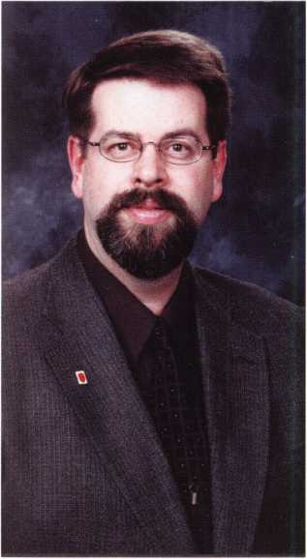

Roger Yost, CML, CPS - trusty mountain institutional locksmith.

***Keynotes***

***April 2001***

Fire King

UNIVERSITY 3

**SECURITY PRODUCTS FOR THE 21 ST CENTURY**

s ^

■

FILE

COLLEGE **G** p

FireKing®

Fireproof Files

DOOR

COLLEGE **O**

Enters™

Security Doors

DIGITAL

VIDEO

COLLEGE **O**

Image Vault®  
Recorders

COLLEGE

Meilink®

Gary® Jk  
NKL®

Fire King University is a comprehensive technical training program comprised of four unique colleges. Safe College is a two-day course where students learn the operation and service of intelligent NKL brand cash handling safes, including the Intellisafe and Autobank. Door College is a one-day course where students learn the technical details needed to install and service Entera Security Doors and associated keyless entry electronics and panic hardware. Digital Video College, a one-day course, covers sales, installation, setup, and operation of Image Vault digital video recorders. File College is for service of FireKing's fireproof files.

Fire King University's Safe, Door and File Colleges are open to all Fire King dealers and Service Provider Network members. Digital Video College is open to all Image Vault dealers and users. Upon successful completion of training, students are certified in the applicable product area.

To obtain a brochure, schedule, or to register call 1-800-457-2424 ext. 697.

mamm 101 Security Parkway

■— U Iff New Albany IN 47150

II IXII |V| Ph 800-457-2424

**SECURITY PRODUCTS** Fax800-227-7513

**for the 21 st century** [www.fireking.com](http://www.fireking.com)

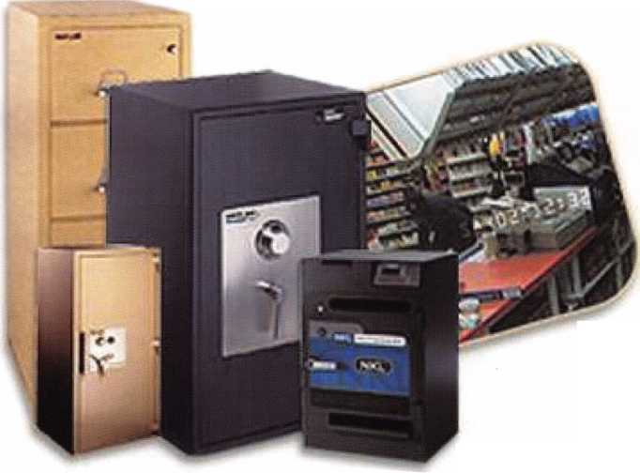

By



Karen Hoffman

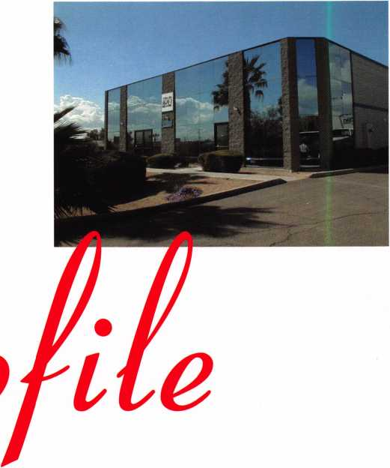

IDN, International Distribution Network is a unique distribution entity in the locksmith industry. It is the holding company of seven regional companies that have flourished in the locksmith industry for many years. Its companies include IDN-Acme headquartered in New Orleans, IDN-Armstrong,Atlanta,IDN-Canada, Toronto, IDN-Hardware Sales, Detroit, IDN-H. Hoffman, Chicago, IDN-M.Taylor, Philadelphia and our newest company, IDN-West,Phoenix.Recent openings include centers in Los Angeles, Minneapolis and Syracuse.

IDN has two new distribution centers opening in the first half of 2001. On March 1 st, the Albuquerque, New Mexico distribution center opened, and on May 1 st, the Montreal Quebec Canada center will open. This brings the total number of IDN distribution centers throughout North America to forty-two. Locksmiths might wonder why IDN has so many inventory outlets. Throughout the years, the one constant we've seen in the security aftermarket is the shortage of capital resources in many of our locksmith customers. Without capital, most secu­rity service businesses never reach their full potential. IDN saw the opportunity to grow its business and make a difference to its customers by making product avail­able at a local level, so that our customers could rely on us to warehouse for them. When we supply inventory quickly and efficiently, the dollars that our customers had previously invested in inventory can now be rein­vested into their businesses in the form of service vans, people, education, training, equipment and technology. The areas that are crucial to the growth of a locksmith service business.

IDN is capable of getting inventory from hundreds of manufacturers quickly into our distribution centers and directly to the locksmith. We can access any one of our



Keynotes

April 2001

locations to find what our customers need. In addi-  
tion to lowering the holding costs of inventory, IDN  
Distribution Centers provide a source of low-cost  
product training and business education classes.  
Localized education can help keep training costs  
down while giving locksmiths access to learning  
opportuinities. IDN also has a tremendous amount of  
experienced sales and service people through out  
North America who are readily available as resources  
for our locksmith customers.

**What's** New **at** IDN?

IDN is keeping up with the ever-changing world of  
e-commerce. IDN has launched a new ultra-friendly  
information and order entry access program.

This program was designed for active  
IDN customers who want more con-

trol over the order process and want  
greater access to information

regarding delivery dates, order  
history, manufacturers product

specifications, current specials  
as well as price increases and  
industry news. The program also

allows customers to create a spe-  
cial stock list for specific jobs, as

well as link to any manufacturers’ site  
that IDN represents. The beauty of the

program is that one doesn't need special soft-  
ware or equipment to use it. All you need is a pass-  
word assigned to you from your local IDN distribu-  
tor. The program, as is all technology, is a work in  
progress. We are using input from our customer users  
to add enhancements, so that it continues to meet the  
ever-changing needs of the locksmith.

exclusively for locksmiths. Also highlighted in the  
brochure is the new Millennium Brass line that fea-  
tures a Lifetime Finish Warranty. Another pamphlet  
made for our customers by IDN is "Collection Tips  
and Techniques for Small Businesses." This booklet  
helps the locksmith improve cash flow, reduce time  
spent on collections, and create more time to earn  
money.

As an international distributor comprised of region-  
al companies, each company manager concentrates  
on being the best distributor in his/her geographic  
area. Experienced, committed people are the key to  
any successful business. At IDN-Acme, for instance,  
Barry Johnson became President last year. Barry has  
a tremendous amount of experience in the

" J|/^" locksmith industry and was previously

Sales Manager for IDN-Acme. John

Burke, with over 25 years of expe-  
rience in the industry, became  
President of IDN-Armstrong, in  
October of 2000. These  
changes, along with many oth-  
ers made across IDN, have  
helped IDN maintain its position  
as a high quality leader in distri-

bution.

***m um mm tm ouu***

*mroHamremmiia-****ms,5omTiT(minmwm***

***m m-msm um of***

**What else** is **new?**

IDN is continually working on being a business guide to its locksmith customers. One of the ways that we accomplish this is to publish brochures and pamphlets to help the locksmtih manage and market his or her business. For instance, IDN has created a Residential Security Hardware brochure that is cus­tomized with the locksmith's label on it and high­lights the LSDA residential lock product line, made

***MtOCKMH.***

Everyday, the locksmith industry changes and IDN continues to change with the industry. Each IDN company is responsible to grow its region, by helping its customers grow and get them the right products.

Among the many product lines recently introduced in IDN are Adesco safes. Alarm Lock provimity locks, Ilco Ultracode key machines, Sentry gun safes, Master Pro Series III, Schlage Everest, Locknetics, IONIT, Trine mini electric strikes, and Assa TE high security cylinders. You can order from your local IDN distributor by calling their 800 WATS line, by faxing, or using the Internet at idn-inc.com.

***April 2001***

Keynotes

ily papers from the 1850's were damp but otherwise fine. Thanks, AMSEC, for making a good product.

1 contacted both of my insurance companies , personal and business, and started the claims process. The next afternoon I met with the fire investigator and an adjuster from each com­pany. Both adjusters refused to enter the building. At this point, while answering their questions, I started to realize the flaws in my planning. Here are a few of the things that I learned to do from the experience that you would do well to consider doing for yourself:

Where do you keep your list of tools and inventory? Do you even have one? I hope you do and do not keep it where I kept mine (inside the house). The forms that the Ins. Co. people gave me to fill out require model numbers, date purchased, purchase price, place of purchase, and the cost to repair or replace. I had to compose this list from memory since all my records were destroyed in a non-fire rated file cabinet. It is nearly impossible to keep from missing important things while doing this from memory .

Do you have replacement cost insurance? This is an impor­tant consideration. I was fortunate enough to have purchased replacement cost as a feature on my insurance. This means any item you replace will be paid full value. Non-replaced items are paid at a drastically depreciated value up to your maximum coverage. .

Do you have enough coverage? I have found I was sadly lacking in this department. Because as a mobile shop, I felt that most of my tools and inventory were in the van, I had reduced the contents valuation in the apartment. Bad Move! It turns out that there was much more inside than I thought. Plan ahead. The small items add up much faster then you think.

Does your policy have a rider to save computer data? Surprise! My business insurance adjuster asked me to get my hard drive out of my business computer. Why? They found a computer wizard for me that was able to extract all my sales, and AR reports from the damaged hard drive. Which had to be completely rebuilt because of water and extreme heat. I latter found this rider not only covers data recovery but also the computer equipment. This means the computers do not subtract from the maximum coverage amount.

Is Your Business Prepared for Fire?

ike many of you, I thought I had made all the right prepa  
rations to protect my business and home. Little did I know.

At 4:00 A.M. on November 28th , 2000, I learned I had only  
begun my preparations.

The fellow in the apartment next to mine awakened me,  
telling me to get out of the building NOW!!!! I grabbed a few

treasures as I left the building but was more concerned with

getting his two year old child out of the building. After the  
fire department arrived, I watched helplessly as fire fighters  
with 9 trucks, from 3 departments, and the ladder truck from  
a local mfg. plant, fought the blaze. For over 8 hours they  
fought to save 35 years of my personal collecting , 6 years of  
business records, my tools, and my library. The fight finally  
ended when they pushed 5' of wall in to my office and shop.  
By doing so, they were able to save the connecting buildings  
on both sides of my apartment and shop. At this point I found  
myself standing out in the street with the few items I carried  
out with me, and an AMSEC fire safe containing a few family  
history papers that I had carried up stairs less than 48 hours  
before.

This safe was an AMSEC 1818. After the fire was contained in the rear of the building; the fireman let me go up-stairs to try and open the safe. I had to kick the collapsed roof away from in front of the dial. Due to the heat and water that it had been exposed to for five hours, the electronic lock would not open. 1 grabbed a few things from inside the house that

were not damaged but could

eventually went,

my keys were^

as I had

lighthe

of tb

ot find my van keys. When

n, I found to my dismay, that

my pocket or in the house

must have felt guilty for the

||e keys, because 5

|y rolled all 300+  
k good friends at  
|.nd opened it for

(shells and fam-

By

**Steven**

**Goodwin**



So, protect yourselves from catastrophe by at least doing these five things:

1. Keep a complete inventory and back up for all your records in a separate loca­tion. (As in a completely separate building.)
2. Take pictures of everything and keep them along with your other insurance records, away from your home or shop. A safe deposit box is good for this stuff.
3. Call your insurance provider and make sure you have enough coverage.
4. Check all smoke detectors and fire extinguishers. OFTEN!
5. Get a fireproof storage unit and use it.

I am still playing a paper work game with both insurance companies, and can only sit and wait for the final results. I have learned a very valuable lesson about the value of life and good friends. Within hours my friends on The Clear Star Network had pulled together to offer their support. They raised money, sent tools and inven­tory to make sure I could keep operating. For this, I am extremely grateful and offer them my gratitude and thanks.

**So please, PLAN AHEAD for the worst! Don't make yourself a victim of lack of preparation.**

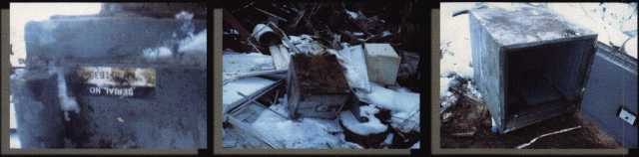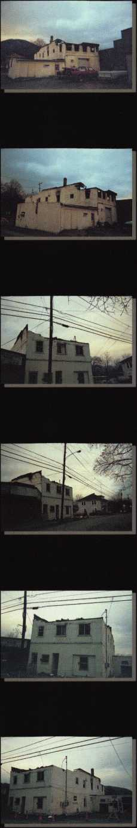

***April 2001***

***Keynotes \*** 37



CHECK OUT ALOA’S NEW ON-LINE LEGISLATIVE TOOL!

Go to <http://wwwaloaorg/news/legislationcfm> and check out ALOA’s new on-line service that connects locksmiths to every member in their state legislature It provides up-to-date information about key issues and gives users quick and easy access to state officials You can contact legislators by customized or personalized e-mails, faxes or standard letters It also conducts a 5 and 9-digit ZIP Code search so that you can identify your state and local officials quickly Check it out today!

CALIFORNIA AB143

Requires locksmiths to maintain a bond of $2,500 for the benefit of persons damaged by a locksmith’s failure to comply with specified duties and restric­tions imposed under existing law

STATUS: 01/25/2001 Introduced

02/16/2001 To Assembly Committee on Business and

Professions

CONNECTICUT SB1323

Establishes licensing and examination requirements for home improvement contractors and telecommunications infrastructure layout technicians STATUS: 03/01/2001 Introduced 03/01/2001 To Joint Committee on General Law

ILLINOIS HB26

Provides that giving notice to the public by yellow page advertisement, through a sign at the facilities of the towing service, or by any other adver­tisement, that the towing service opens motor vehicle locks to enable a vehi­cle to be moved without towing does not constitute holding oneself out to the public as a locksmith if the advertisement does not use the word “locksmith” STATUS: 01/10/2001 Introduced 01/10/2001 To House Committee on Rules 01/31/2001 Sent to House Committee on Registration and Regulation

03/15/2001 Hearing in the House Committee on Registration and Regulation:Do pass Amendment

ILLINOIS HB2219

Changes a defined term from burglar alarm system to alarm system; adds surveillance television systems to the definition

STATUS: 02/22/2001 Introduced

03/15/2001 To House Committee on Registration and

Regulation:Do pass Amendment

ILLINOIS HB2536

Amends the Private Detective, Private Alarm and the Private Security and Locksmith Act; requires applicants to provide a permanent registration card of their fingerprints electronically

rather than on inked cards; expands the categories of persona allowed to carry firearms while engaged in the performance of their duties STATUS: 02/26/2001 Introduced 03/15/2001 To House Committee on Registration and Regulation:Do pass Amendment

ILLINOIS SB115

Amends the Illinois Vehicle Code; provides that other than at the time of sale of the vehicle, no vehicle dealer may issue to any person a new key to a vehi­cle unless the person can prove that he or she is the owner of that vehicle by the certificate of title or the vehicle registration card

STATUS: 02/01/2001 Introduced 03/07/2001 From Senate Committee on Transportation: Postponed: Do pass with amendment

ILLINOIS SB967

Provides for regulation of electricians and electrical contractors; provides that performing unlicensed electrical work, when a license is required by this Act, constitutes a business offense for the first violation and a Class A mis­demeanor for a second or subsequent violation; provides for concurrent exer­cise by home rule units

STATUS: 02/22/2001 Introduced 03/08/2001 S ub-committee

INDIANA HB1545

Requires employers to disclose to an employee or prospective employee any type of electronic monitoring of employees Limits the extent to which an employer may electronically monitor their employees STATUS: 01/11/2001 Introduced 01/11/2001 Referred to Committee on Labor and Employment

01/24/2001 Committee report: do pass, adopted

MARYLAND HB224

Authorizes the Secretary of State Police to adopt regulations to establish fines for specified violations; requires specified individuals to be licensed as private detectives, security guards, or security systems technicians by the Secretary of the State Police before soliciting and engaging in business STATUS: 01/23/2001 Introduced 02/27/2001 Committee amendment adopted on House floor

03/05/2001 To Senate Committe on Judicial Proceedings

MISSISSIPPI HB148

Regulates the installation and service of burglar and intrusion alarm systems; defines certain terms; creates the Mississippi electronic security board of licensure and provide for it membership and administration; provides the powers of the board; provides licensing requirements; provides exemptions from this act; provides for violations of this act; provides for uniformity; pro-



***Keynotes***

***April 2001***

ides for its administration

STATUS: 01/02/2001 Introduced

01/03/2001 To House Committee on Judiciary B

01/24/2001 From House Committee on Judiciary B:

Do pass with substitute

01/30/2001 Passed House

01/30/2001 SB2446 Died in Committee

02/09/2001 House Bill Sent to Senate Committee on

Business and Finance

02/28/2001 Died in Committee

**JEW YORK AB3971**

istablishes security requirements to be fulfilled by owners of multiple [welling units including deadbolt locks, window pins, adequate lighting, olid core doors, intercoms and optical viewers; provides requirements for ach such security measure

STATUS: 02/05/2001 Introduced 02/05/2001 To Assembly Committee on Housing

MasterLink Security Products

ROGER ALEXANDER-TUTTLE

“...understanding the needs of locksmiths...”

Mortise/Rim/Knob Cylinders • Storefront Door Hardware  
Cabinet Locks • Chain • Key Blanks • Padlocks • Pins ...and more

Local: (954) 730.9669 • Toll Free: (877) 347.9669

Fax: (954) 486.0575

e-mail: [masterlink@mindspring.com](mailto:masterlink@mindspring.com)

3863 NW 19th Street, Lauderdale Lakes, FL 33311

Its True

Marray has developed the first  
screwless door loop.

**3REGON HB2563**

Creates Class A violation of unauthorized duplication of keys marked “Do slot Duplicate”

STATUS: 01/22/2001 Introduced 01/25/2001 Sent to House Judiciary Committee

**rEXAS HB1077**

’rovides for the voluntary registration of locksmiths, and defines the profes- ion in the Code

STATUS:01/30/2001 Introduced

**JTAH HB222**

dodifies the Individual Income Tax Act to create a refundable individual ncome tax credit for the purchase of a residential security container STATUS: 01/15/2001 Introduced 01/17/2001 Sent to House Committee on Revenue and Taxation

02/05/2001 Failed in the House 02/06/2001 Motion to Reconsider 02/28/2001 Enacting Clause Struck

JOIN THE LEGISLATIVE ACTION NETWORK TODAY!

Vs we continue to expand our resources and become more competitive in the leg- slative arena, we need the monetary resources to match our successes You can lelp with as little as $14.95 to the Legislative Fund This is only the minimum hat we are asking, and encourage you to give more if you can Those that con- ribute will be given a Legislative Action Network Member kit to use in their ;rass roots efforts Members who donate $100 or more become Legislative Vction Network Council members, and enjoy the following extra benefits: Direct nput into the legislative strategic plan that guides all legislative activities; Jiscounts on ALOA bookstore items; 10 % rebate on all ACE classes; Complimentary Legislative Convention merchandise Join today by contacting jovernment Affairs Manager Tim McMullen at tim@aloaorg

Aluminum ma­terial means true anodizing.

No off color powder coat­ing or painting

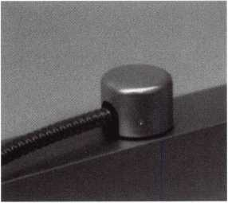

Standard 18”  
length. Can be  
ordered in cus-  
tom lengths

Plastic base stops  
shorts and pro-  
tects wires

Screwless base and cap means you drill two 1/2 inch  
diameter holes, pop the base into the hole, wire your  
system and snap on your covers. Simple as 1, 2, 3.

**Here’s the best part We are giving away a**

FREE SAMPLE TO THE FIRST 1 OO CALLERS WHO MEN-  
TION THIS ADD. A $14.40 WHOLESALE PRICE VALUE.

CALL TODAY, IT’S FREE!!

1-800-500-1449

**Marray *enterprises*, *inc.***

At **Marray,** we’re not **just** modifiers, we’re Master Hardware Modifiers™ **1128 Walsh Ave., Santa Clara, CA 95050* [www.marray.com](http://www.marray.com)**

April 2001

39

Keynotes



EMPLOYMENT

Experienced Locksmith Wanted

Live, work, and enjoy Florida’s east coast  
in beautiful Brevard, Co. Must be  
able to run after hour calls. Top salary and

or commission. Call  
**1*888-752-7233**

Experienced Security Techni

Needed

Growing, established comn^cial lock  
company with annual saieiexceeding $1  
million seeking experienced security tech-  
nician. Stocked van provided with inven-  
tory, key machines and tools. Applicants  
must have knowledge of commercial lock-  
smithing, including extensive master key  
systems (Medeco, Besi||Schlage, Sargent,  
etc.). Architectural hardware installations,  
including locks, hinges, Ijgsers, exit  
devices, continuous hinges aifk hollow

metal door replacements. No automotive,

no lockouts, no 24-hr. service. Week!

free.

Awesome opportunity for self-motivated,  
hardworking individuals. Salary commen-  
surate with experience. Paid holidays,  
vacation, medical and dental. Retirement  
plan.

Contact:

Redford Lock Company, Inc.

26515 Grand River Ave.

Redford, MI 48240  
Phone 3131535-0400  
Fax 3131535-0559  
e-mail [redfordlock@aol.com](mailto:redfordlock@aol.com)

Experienced Technician Needed

Mid-sized company in sunny California (by the beach) seeking a person with a pos­itive attitude and a friendly smile. We offer paid vacations, paid holidays, med­ical and dental insurance, a SEP-IRA pro­gram, company provided vehicle, tools (except hand tools). We cater mainly to the commercial customer with very little automotive. On call is NOT mandatory. Access Control and safe knowledge is pre­ferred but not required.

Contact: Paul

Phone: 831143^415 fax: 831^fff487 e-mail:aasafe @yahoo, com

mith Wanted

lock shop in the Palm Springs area

of California is looking for an experienced  
locksmith for field work. Must be profi-  
cient in master keying, safety deposit  
boxes and working knowledge of safes.  
Salary plus commission. Health insurance  
benefits and 401(k) plan. Please fax  
resume to: 760/779-1811 or call 760/346-  
5214.

Tony's Lock & Security Service

We are located in S. Orange County,  
California and are in need of a locksmith  
with a minimum of two years experience  
in commercial, safes, high security; access  
control a plus. Van and tools provided by  
company. Excellent pay, bonus, overtime,  
retirement, health insurance, sick leave,  
paid vacation and holidays. Send resume or  
contact:

Tony's Locksmith

**|5>j** 492-5700

(§^M92f)246fax

Experienced Locksmiths Wanted

We at Top Security Locksmiths, Inc. are

currently seekififpjwo locksmiths. We are

a full service lockst^to/ alarm installation  
company. We have tw^^op locations and  
four service vehicles. looking for

individuals trained in Masfl§||eying and  
basic lock servicing. ElectrolS^Access

Control and Alarm installation #plus,

along with Automotive locksmi

skills. We are located right in the heai

the Jersey Shore, so automotive plays a big  
part in our business. We offer a benefit  
package and top pay in the area. Clean  
driving record and must be bondable.  
Send resume or contact:

David C. Rihle

Top Security Locksmiths, Inc.

(723) 899-1414  
(732) 899-2220 fax  
www. top-security, com

Wanted:Experienced Technicians

Lock into your future now! If you are an experienced, intelligent technician, and desire a secure future, come join our tealh?3 We are a full servie commercial^ residen­tial security service (locks, keys, safes, cctv, access control, doors related hard- ware). We offer: large sign oh bonus, top wages, company vehicle, 40IK, paid vaca­tion, paid holidays, health benefits, new uniforms, cross-training, and JOB SATIS­FACTION. We are looking for the best tech’s who ae ready to be treated and com­pensated as professionals. Contact:

Bass Security Services, Inc.

(216) 755-1200 Ext:128

(216) 755-1220 fax

e-mail1 [rmesnick@bass-security.com](mailto:rmesnick@bass-security.com)

Experienced Service Technicians Needed

Due to continued growth, we are looking for locksmiths, door operator technicians and low voltage technicians. Our company has been in business since 1880 and is located in the beautiful Pacific Northwest. Argens Inc. is a multidimensional compa­ny. We target commercial and industrial accounts. Our company specializes in gen­eral locksmithing, electronic security (card access & CCTV) and door servicing. We are an employee driven company with excellent pay, benefits, sales incentives, and can offer advancement as our growth continues. Send resume to:

Steve Templeton Argens Incorporated 84 S. Main Street Seattle, WA 98104 (206) 623-2662 (206) 622-5056fax [www.argens.com](http://www.argens.com)

Service Technician Wanted

Locksmith service technician needed at  
fast paced growing firm. Looking for great  
pay, positive work environment and full  
benefits package? Fax resume to:

Mr. Schmidt

Loss Prevention 'Wjlfiems Inc.

22865 Savi RancBT^^py #B

Yorba Linda, CA 9288

(714) 279-0092 fax

***Keynotes***

***April 2001***

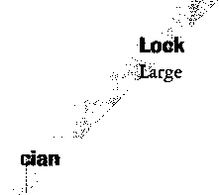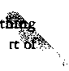

WANTED TO BUY/SELL For Sale

3 curds clipper #15 guns, 1 setup for 47 degree cuts, 1 special case, holds 39 cams, 120 carriages, have 46 cams, 75 carriages $2500. Also have Reed Code Book #1-14, $550. Please contact me at Masons Locks & Keys

PO Box 371270, Key Largo, FL, 33037 or 1-303-451-0193 or 1-386-322-4004

Two Way Radio System For Sale

Used 800 MHz trunked two way radio system with base unit and 36 hand held units with chargers, batteries, and cases. For more information check out our web­site.

$4000.00 or Best offer Liberty Lock and Safe (702) 871-5397 [www.libertylock.com](http://www.libertylock.com)

■ BUSINESSES FOR SALE Live In Paradise!

Located in Paradise, California. Well equipped shop and van. Turn key opera­tion. $50,000 takes it all. Owner wishes to retire. For more information call: (530) 872-2998

Established Locksmith Business

Established locksmith, bicycle repair and UPS shipping center in Greenville, MS. Two or more of everything, vans, code machines, duplicators, computers, etc. 1999 gross $225,000. Priced to sell at $75,000. For more information contact Jerry at (662) 335-9070.

Locksmith and Security Business for Sale

Established 18-year old business in a very nice business and resort area of western Wisconsin. Business and real property asking price: $550K. Business is located on main level with two bedroom apts. On second level. Apartment income over $10K per year.The current owner will stay with the buyer for up to one year to train

buyer and help expand the business.

Call Harry Baker at 8001966-2913.

Business For Sale

Well established locksmith and safe com­pany in sunny Santa Cruz, California. Many commercial accounts. Business has been in the same location for 41 years. Two+ years left on lease. Two fully equipped mobile units. Must sell due to health.

For more informationf call 831/438- 2050. Serious inquiries only, please.

Business for Sale

Successful locksmith business in northern California. Two offices. One in Eureka, the other in McKinleyville. Largest volume in the area. Time to retire. Gross volume last year was almost $300K. Includes latest equipment, all fixtures, all tools and three vehicles. $199,000.

Call Bill Davidson, 707/441-1800.

Classified Advertising

Classified advertising space is provided

charge to ALOA members, and for a fee of  
$.60 per word, $15 minimum for non-mem-  
bers. Classified ads may be used to advertise  
used merchandise and overstocked items for  
sale, “wanted to buy” items, business oppor-  
tunities, employment opportunities/posi-  
tions wanted and the like. Members or non-  
members wishing to advertise services or new  
merchandise for sale may purchase a  
“Commercial Classified Ad,” for a fee of  
$1.30 per word, with a minimum of $40.  
Each ad will run for two issues. For blind  
boxes there is a $5 charge to members and  
non-members. All ads must be submitted in  
writing to the ALOA office by the fifteenth  
of the month, two months prior to issue date.  
Send to Keynotes Classifieds, 3003 Live Oak  
St, Dallas TX 75204-6186. ALOA reserves  
the right to refuse any classified advertise-  
ment that it deems inappropriate according  
to the stated purpose of the classified adver-  
tising section.

INTERCHANGEABLE  
COREPRODUCTS

Interchangeable

with:

•BEST

* ARROW
* FALCON

Quality • Price KILLEEN SECURITY  
Delivery PRODUCTS

That's what KSP is all about!

Ask your wholesaler about  
our drop shipping.

***33 Hermon St.  
Worcester. IUA 01610  
Phone (508) 798-3200  
Fax (508) 753-2183***

***April 2001***

Keynotes

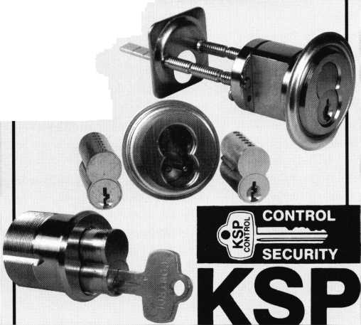

**[MANUFACTURER**

•A & B Safe Corp.

(800) 253-1267 FAX (856) 863-1208

•Abloy Door Security

(514) 335-9500 FAX (514) 335-0430

•Abus Lock Company

(800) 352-2287 FAX (612) 509-9939

•Adams Rite Manufacturing Co.

(562) 699-0511 FAX (562) 699-5094

•Adesco Safe Manufacturing Co.

web: [www.adesco.com](http://www.adesco.com) (800) 821-6803 FAX (562) 408-6427

•Adrian Steel Company

web: [www.adriansteel.com](http://www.adriansteel.com) (800) 677-2726 FAX (517) 265-5834

•Alarm Lock Systems, Inc.

(800) ALA-LOCK (516) 789-3383

•American Lock Co.

(708) 534-2000 FAX (708) 534-0531

•American Security Products (AMSEC)

(800) 423-1881 FAX (909)685-9685

•Baldwin Hardware Corp.

(610) 736-4012 FAX (610) 796-4493

•Buddy Products

1 (800) 886-8688 FAX (312) 733-8536

• BWD Automotive

9(334) 874-9001 FAX (334) 874-6011

•Curtis Industries

1(800) 555-5397

•DSC Group of Companies

(905) 760-3000 ext. 2200 FAX (905) 760-3040

•Door Controls International

(800) 742-3634 FAX (800) 742-0410

•ESP Lock Products, Inc.

(978) 537-6121 FAX (978) 534-9109

•Grobet File Co. of America

(800) 962-7242 FAX (800) 243-2432

•HPC, Inc.

(847) 671-6280 FAX (847) 671-6343

•llco Unican

(252) 446-3321 FAX (252) 446-4702

* In Out Systems, Inc.

(450) 444-5949 FAX (450) 444-4856

•Intellikey

(800) 226-0703 FAX (407) 724-0811

•Jet Hardware Mfg. Co

(718) 257-9600 FAX (718) 257-0973

•KABA High Security Locks

(860) 621-3601 FAX (860) 621-9727

•KEY-BAK; Div. of W. Coast Chain Mfg,

(909) 923-7800 FAX (909) 923-0024

•Knaack Manufacturing Co.

(800) 456-7865 FAX (815) 459-9097

•LAB Security

(800) 243-8242 FAX (203) 583-7838

•LCN Closers (Division of Ingersol)

(815) 875-3311 FAX (815) 875-3222

* La Gard, Inc.

(310) 325-5670 FAX (310)325-5615

•Lucky Line Products

(619) 549-6699 FAX (619) 549-0949

•M.A.G. Engineering & Mfg. Inc.

(714) 891-5100 FAX (714) 892-6845

•MARKS USA

(516) 225-5400 FAX (516) 225-6136

•MARRAY ENTERPRISES

(408) 970-0213; FAX (408) 970-8767

•Master Lock Company

(414) 444-2800 FAX (414) 449-3114

For more complete

Keynotes

***April 2001***

•Medeco Security Locks

1. 380-5000 FAX (540) 380-5010

* Meilink Safe Company

(800) 634-5465 FAX (800) 896-6606

•One Lock, One Key Inc.

(817) 860-1011 FAX (817) 275-6839

* ROFU International Corp.

(800) 255-7638 FAX (253) 922-1728

•STRATTEC Security Corp.

(414) 247-3333 FAX (414) 247-3329

•Sargent & Greenleaf, Inc.

(606) 885-9411 FAX (606) 887-2057

•Schlage Lock Co.

(800) 847-1864 FAX (800) 452-0663

•Schwab Corporation

(765) 447-9470 FAX (765) 447-8278

•Securitron Magnalock Corp.

5(800) 624-5625 FAX (702) 355-5636

•Security Door Controls

(805) 494-0622 FAX (800) 959-4732

•Security Solutions

(405) 376-1600 FAX (405) 376-6870

* Sentry Group

(716) 381-4900 FAX (716) 381-8559

•Sully Tools Inc.

(703) 689-3416 FAX (703) 787-0869

•Taymor Industries, Inc.

(800) 388-9887 FAX (800) 288-8133

•Trine Products Corporation

(718) 829-4796 FAX (718) 792-9127

•Videx, Inc.

1. 758-0521 FAX (541) 752-5285

•Visonic, Inc.

(800) 223-0020 FAX (860) 242-8094

information visit our Web site at aloa.org



•W-Lok Corporation

(616) 355-4015 FAX (616) 355-4295

•Yale Security Inc.

(800) 438-1951 FAX (800) 338-0965

**DISTRIBUTORS**

•Accredited Lock Supply Co.

(800) 652-2835 FAX (201) 865-5031

•Ace Lock & Security Supply Co.

(800) ACE-LOCK (800) ACE-FAX4

•ADI

(516) 692-1000 FAX (516) 692-3457

•Akron Hardware Consultants, Inc.

(800) 321-9602 FAX (800) 328-6070

•American Security Distribution

(714) 996-0791 FAX (714) 579-3508

•Andrews Wholesale Lock Supply

(717) 272-7422 FAX (717) 274-8679

* Boyle & Chase Inc.

(800) 325-2530 FAX (800) 205-3500

* Clark Security Products, Inc.

(800) 854-2088 FAX (619) 974-5284

* Cook's Building Specialties

(505) 883-5701 FAX (505) 883-5704

•DiMark International

3(800) 235-2435 FAX (805) 928-8034

* Dire's Lock & Key Co.

(303) 294-0176 FAX (303) 294-0198

•Direct Security Supply, Inc.

(800) 252-5757 FAX (800) 452-8600

•Doyle Security Products

(800) 333-6953 FAX (612) 521-0166

•E. L. Reinhardt Co., Inc.

(800) 328-1311 FAX (612) 481-0166

•Foley-Belsaw Company

(800) 821-3452 FAX (816) 483-5010

•Fried Brothers, Inc.

(800) 523-2924 FAX (800) 541-3489

•HS&S Wholesale Distributors

1(800) 521-2202 FAX (313) 342-7580

•Hans Johnsen Company

(214) 879-1550 FAX (214) 879-1530

•Howard Keys

(704) 598-2291 FAX (704) 598-9110

•IDN, Inc.

(817) 421-5470 FAX (817) 421-5468

•Intermountain Lock & Supply Co

(800) 453-5386 FAX (801) 485-7205

•Jo-Van Distributors Inc.

(416) 752-7249 FAX (416) 752-3845

•Lockmasters, Inc.

(800) 654-0637 FAX (859) 885-7093

• Locks Company

(800) 288-0801 FAX (305) 949-3619

•The Locksmith Store Inc.

(847) 364-5111 FAX (847) 364-5125

•M. Zion Company

(212) 349-8677 FAX (212) 964-0495

•McDonald-DASH Locksmith Supply

(800) 238-7541 FAX (901) 366-0005

•McManus Locksmith Supply, Inc.

(702) 333-9112 FAX (704) 332-8664

•MARRAY ENTERPRISES

(408) 970-0213 FAX (408) 970-8767

•Securite.com

(800) 241-3930 FAX (619) 974-5269

* Omaha Wholesale Hardware

(800) 238-4566

* Sentry Security Fasteners

(309) 693-2800 FAX (309) 693-2872

•Southern Lock and Supply Co.

(800) 237-2875 FAX: (800) 447-2299

•Stone & Berg Wholesale

(800) 225-7405 FAX (800) 535-5625

* Strauss Safe & Lock Company

(515) 288-9571 FAX: (515)288-9752

•Tanner Bolt & Nut Corporation

(718) 434-4502 FAX (718) 434-3215

•Taylor Securtiy & Lock Co.

(301)948-7670 FAX (301) 948-1029

* Timemaster, Inc.

(785) 232-8705 FAX (800) 798-8463

•Top Notch Distributors, Inc.

(800) 722-4210 FAX (800) 248-3620

* U.S. Lock Corporation

(800) 925-5000 FAX (800) 338-5625

•Webster Safe & Lock Company, Inc.

(901)332-2911 FAX (901) 332-2878

**SERVICE**

•Alarm Monitoring Service, Inc.

(504) 454-2163 (504) 456-8737

•Allstate Insurance Company

(847) 402-8196 FAX (847) 326-7509

• Diamond Software

(770) 227-7650 FAX (770) 227-1699

• Dugmore & Duncan Inc.

(888) 384-6673 FAX (888) 329-3846

***April 2001***

***Keynotes \*** 43

a u t b o r a

**I** Sal Dulcamaro, CML*, has been in the*

*locksmith business for over 26 years.* He *is* ^^1 *the president of All* Pro *Security*, *Inc. in Michigan and*

■EH *has been an* ALOA *member for 1*9 *years.* A *past president of the Locksmith Security Association of Michigan. Sal*

La _ I *currently serves as editor of the association newsletter.* He

was *named Keynotes Author of the Year” for 1996 and 1997. He is also* a *contributing editor for Keynotes. Find Sal on the internet at:* http: *IIhome, earth* l*ink. net! -lockwriter.*

*Denise M. Lopez, CRL*, *has been in the locksmith business for the* past 17 *years. She was an* "*in-house*" *locksmith for* Rockwell *International* for 9 years, *worked for a distributor for 4 years, and is currently* employed as a *manufacturer's representative for Security Hardware,* Inc. *She has been* active *in local associations for over 10 years, and became an* ALOA *certi­*fied *instructor in 1999.*

*Tom Seroogy is in the new Automotive division* of Lockmasters. He *has been the* Product Manager *for* BWD Automotive *(formerly known as* All *Lock).* His *many years* of technical *expertise* in the *automotive* field and as a contributor to automotive locksmith *education have* created a much sought after demand for his popular classes. Tom has developed the new Automotive *Locksmithing I* & II *classes* for ALOA to help prepare locksmiths *for the* PRP *automotive electives.*

*B*

*Roger Yost,CML, CPS heads up the* lock depart-  
*ment at the Utah State University in Logan,* UT.

*Steve Goodwin owns and operates Steve's Locksmith* Shop in *Winterville,* NC.

|  |  |
| --- | --- |
| AD INDEX  Inside Front Cover Strattec | |
| 5 | Stam Insight |
| 7 | IntraLock |
| 13 | VIDEX |
| 15 | MAG |
| 23 | ALOA PRP books |
| 27 | SpeedyPik |
| 33 | Fire King |
| 39 | Master Link |
| 39 | Marray |
| 41 | KSP |
| 44 | ABUS |
| Inside Back Cover Safetech 2001 | |
| Back Cover | Hickock |

**(fi^liKi)** Innovation saves you time and money again!

Yale 8®

Kwikset®

Schlage C®

Schlage C-L®

Corbin®

Sargent®

Weiser-Falcon®

Arrow®

Russwin®

0-Bar®

Pinning

Window™

One padlock  
does it all!  
No adapters!

Innovation at its finest! The new E-Z Bar™ cylinder for the ABUS 83 Series padlock reduces costs even further. Time is money — and your time is valuable. Accurate, reliable pinning has never been faster than with our new pinning-window cylinder that allows you to see the shear line more clearly. Stop spending your time with less-reliable and low-precision cylinders. Buy the new 83 Series padlocks from ABUS, the leader in ISO-9002 rekeyable padlocks!

Order Toll-Free: **800-352-2287** See Our Latest Products: **[www.abus.com](http://www.abus.com)**

ABUS Lock Co. • 3555 Holly Lane North, Suite 20 • Plymouth, MN 55447

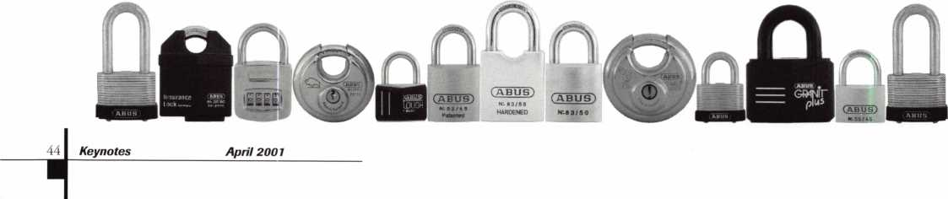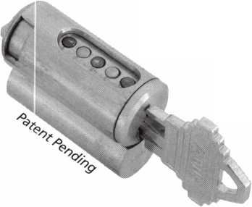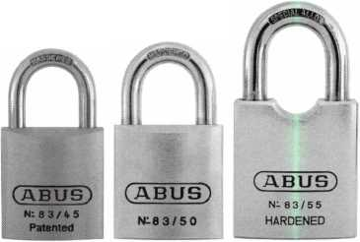

TECHNOLOGY KNOWS IF Y

REN'T KEEPING UP WITH IT

BEFORE ANYONE ELSE FINDS OUT, LOOK INTO SAFETECH 2001

with the evolution of their industry it shows  
of revenue, of customer confidence.

iona

Focus on where your professional future is going at SAFETECH 2001 in St. Louis, Missouri,  
n a city that fires the imagination, you will discover safe technology advances you never imagined possible  
For more information ca II 214.827.7233 , or email [convention@savta.org](mailto:convention@savta.org).

SAFETECH 2001—A Safe Odyssey.

**SAFETECH**

**2001**

A SAFE ODYSSEY

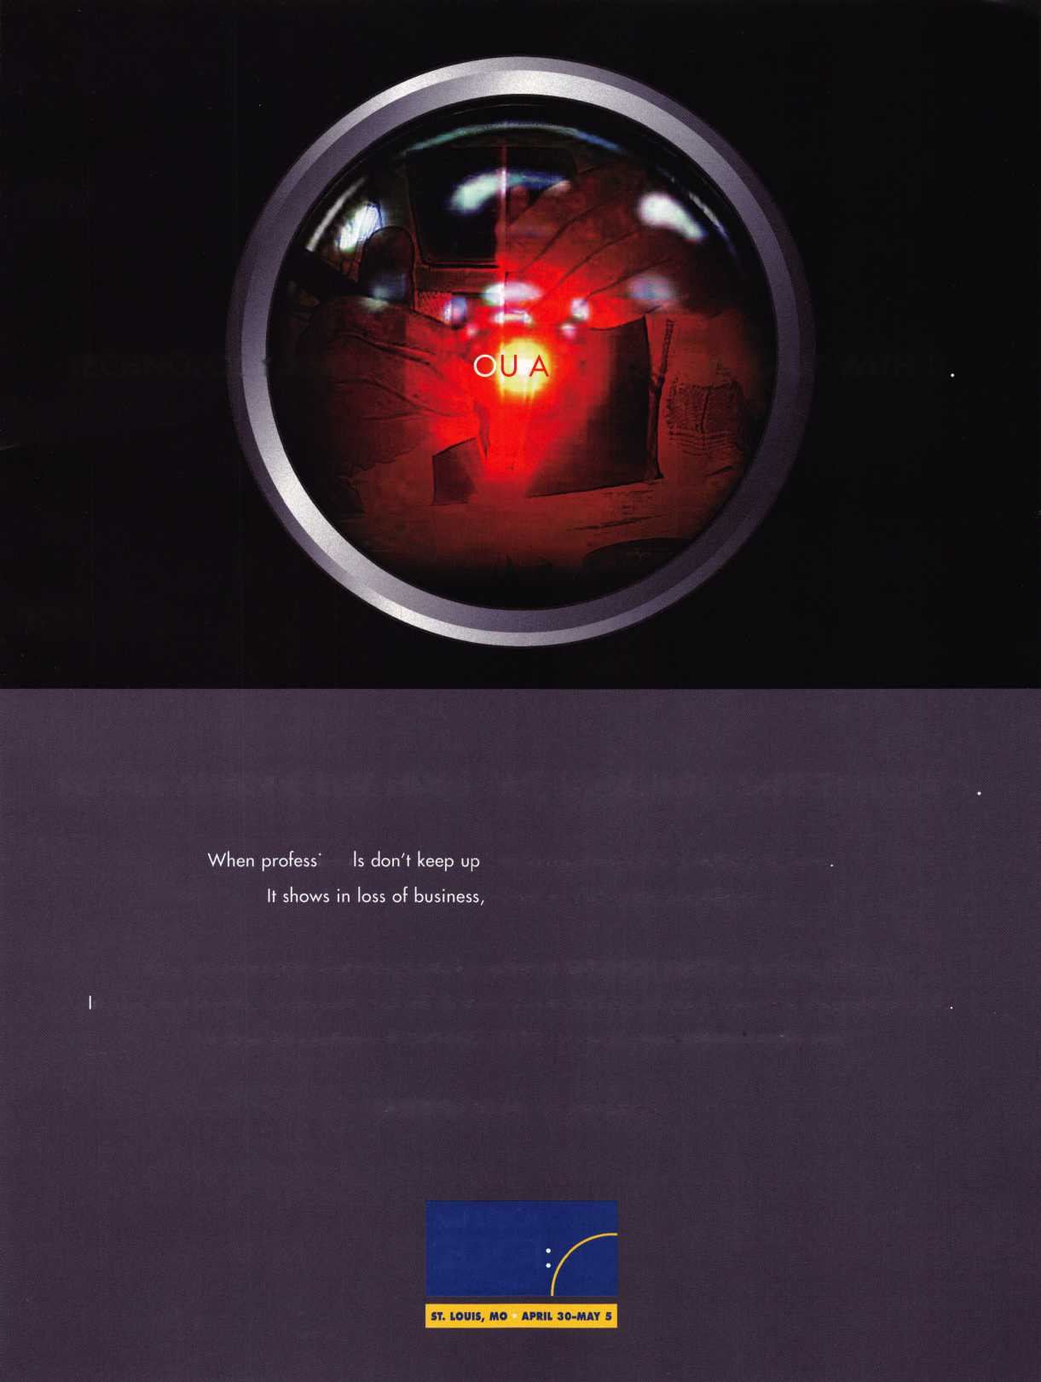

**Jump ahead of the competition  
at warp speed and see your profits soar.**

**Hickok’s New Generation STAR transports you with its advanced programming  
for keys to Ford-Lincoln-Mercury vehicles with passive antitheft systems.**

**Program vehicle keys through MY2000 with Hickok’s NGS Model 800-8LA—$1995**

**HICKOK**

INCORPORATED

phone 800/342-5080  
[www.hickok-inc.com](http://www.hickok-inc.com)

